**ST. AGNES COLLEGE (AUTONOMOUS)**

**MANGALORE-575002**



**A PROJECT REPORT ON**

**“HANDY MANDY SERVICES”**

Submitted in partial fulfilment of the requirement

For the Award of Degree in

**Bachelor of Computer Application**

2022-2023

Submitted by

**Smina Shetty (20851)**

**Lolita Babitha Serrao (20829)**

**Ronali Jane Dsa (20836)**

Under the guidance of

**Internal guide: External guide:**

**Mrs. Preetha Tauro**

**St. Agnes College**

**Mangaluru**



ST. AGNES COLLEGE

(AUTONOMOUS)

**MANGALURU - 575002**

DEPARTMENT OF COMPUTER APPLICATIONS



CERTIFICATE

This is to certify that the project entitled “Handy Mandy Services” has been carried out by

Name (Reg No)

**Smina Shetty 20851**

**Lolita Babitha Serrao 20829**

**Ronali Jane Dsa 20836**

Class …….…. Semester…... for the year 2022-2023.

Submitted in partial fulfilment of the requirement for the Award of the Degree in “Bachelor of Computer Applications”.

Valued at the End Semester Examination of May 2023

Examiners:

1.......................

2........................

Date: .................

…………….

Project Guide

………………………….. ……………..

Head of the Department Principal

**(Certificate of qtech)**

**DECLARATION**

We hereby declare that the project entitled HANDY MANDY SERVICES submitted to St Agnes college is a record of an original work done by us during the year 2022-2023 under the guidance and supervision of our internal guide Mrs. Preetha Tauro, St Agnes college (Autonomous), Mangaluru and External guide.

This Project work is submitted in the partial fulfillment of the requirement for the award of BACHOLOR’S DEGREE IN COMPUTER APPLICATIONS.

The result embodied in this project has not been submitted to any other institute for the award of any degree or diploma.

**Smina Shetty (20851)**

**Lolita Babitha Serrao (20829)**

**Ronali Jane Dsa (20836)**

Bachelor of Computer Application,

St. Agnes College (Autonomous),

Bendore, Mangaluru- 575002

Place: Mangaluru

Date:

**ACKNOWLEDGEMENT**

We express our gratitude to everyone who contributed and supported us through the course of this project. We are thankful for their aspiring guidance and friendly advice during the project. We are sincerely granted to them for sharing their truthful views on a number of issues related to the project.

We would like to thank our parents for their constant support and help with ensuring this project would reach up to its mark and for its successful completion. We express our warm thanks to Sr. Dr. M. Venissa A.C, Principal of St. Agnes College, Mrs.

Head of the Computer Application and the Faculty of Computer Application, our Internal guide Mrs. Preetha Tauro for the giving their support, necessary advices and guidance throughout the project which were extremely valuable for our study both theoretically and practically.

We would also like to thank out External guide and all the people who provides us with the facilities being required and conductive conditions for our project

**INDEX**

|  |  |  |
| --- | --- | --- |
| **SL.NO** | **TITLE** | **PAGE.NO** |
| **1** | **Synopsis** |  |
| **2** | **Software Requirement Specification** |  |
| **3** | **System Design** |  |
| **4** | **Database Design** |  |
| **5** | **Detailed Design** |  |
| **6** | **Coding** |  |
| **7** | **Testing**  **and Implementation** |  |
| **8** | **User Manual** |  |
| **9** | **Conclusion** |  |

**SYNOPSIS**

**Project Proposal**

## Title of the project:

**Handy Mandy Services**

## Introduction:

## “Handy Mandy Services” is a website which is very useful for people who is seeking for part-time job. It provides students to get part-time job by selling their product. The purpose of this web application is a great way to allow customer to easily purchase the product and provide a way for the students to manage and track their sales. This web application creates a platform, where students can offer their skills and services to people who need them. It provides a convenient and cost-effective way for individuals to access the services they need.

## Objectives of the project:

1. The main objective of this web application is to provide a convenient and accessible platform for customer to purchase the product, while also allowing the students to showcase their entrepreneurial skills and generate revenue.
2. To help students gain valuable work experience and develop their professional skills.
3. To generate revenue and profits by selling their products online.
4. This website facilitates the connection between students who are looking for part-time jobs and people who need their services.
5. This can be achieved by creating an easy-to-use platform for both parties can sign up, post and search for services.

## Project Category:

Web-Based Application Using RDBMS

## Languages to be used:

* Front-end: HTML, CSS, JavaScript
* Back-end: MySQL, PHP

## Hardware Interface:

1. Processors: Intel Pentium dual-core or above
2. RAM: 2GB and above
3. Hard disk Utilization:40GB and above
4. Input Devices: Mouse, Keyboard

### Software Interface:

1. Browser: Internet Explorer, Google Chrome, Mozilla Firefox
2. Server: Apache
3. Editor: Sublime Editor

## Module description:

## Admin:

* **Login**- they will enter website using username and password.
* **Manage users**- can view, delete,approve and update the client and student details.
* **Products-** can view the product details.
* **Orders-** can view the order details.
* **Jobs-** can view the jobs details.
* **Dashboard- you** can see all the details of the entire website in brief.
* **Settings-** you can change the password.
* **Log out**- admin can logout.
* **Payment**-the admin can keep the track of all payments made by the customers when they are buying the products from the student.
* **Feedback** -can view feedback given by the customer and students.

### Students:

* **Register**-can register by giving basic details of themselves.
* **Login**-can login using his/her username and password.
* **Create portfolio**- allow you to edit or modify your details.
* **Products-** you can give details and delete of the products and also view orders.
* **Jobs-** you can view all and select jobs made by the clients.
* **Contact-** you contact and give feedback to the admin.
* **Logout-** students can logout.

### Client:

* **Register-** can register by giving basic details of themselves.
* **Login-**can login using his/her username and password.
* **Create portfolio**- allow you to edit or modify your details.
* **Jobs-** you can view applicants and manage jobs
* **Products-** you can view products, place orders and do the payments
* **More-** you view orders, contact the admin, and learn about us.

**Innovativeness and Usefulness:**

* Based on present situation of students and their needs, our team popped up with the idea to create an online platform to provide platform jobs for students.

**Limitations:**

* Cannot predict whether the students are available for all the time for part time jobs.
* Customers are not sure whether the students has the experience to be up to the jobs.

### Future Scope:

* In future we’ll convert it into an android or iOS application.
* Inbuilt video features can be added for the interaction between the users.

**SOFTWARE REQUIREMENT SPECIFICATION**

**INTRODUCTION**

Handy Mandy services website that aims to connect students with the people who need services on their local communities. The website allows students to find part time jobs that can help them earn some extra money while they are studying. At the same time, it will provide a convenient and reliable services for people who need help with the tasks and errands.

The project will consist of various modules that will handle different functionalities of the website, such as product listing, service request , order management, payment processing and user authentication.

**PURPOSE**

The purpose of SRS document is to provide a detailed overview of the requirements for website designed by students for the purpose of selling products to customers. The website is intended to be a user friendly and interactive platform that enables customers to browse, select, and purchase products with ease.

This website will provide a platform to connect students with people who require services such as tutoring, pet care, gardening, cleaning, cooking and other part time jobs. This website help students in gaining practical experience while earning money for their expenses.

**SCOPE:**

* The website will be user friendly, efficient, and secure to facilitate transactions and communication between customers and student.
* The website will have a secure payment system that allows customers to make purchase with their credit or debit card.
* The website will have a list of available students with their skills, rates and availability.
* It will serve as a platform for common people to hire students to provide services.

**ACRONYMS ABBREVIATION:**

SRS: - Software requirement specification.

W.W.W: -Word wide web

RAM: -Random Access Memory.

HTML: -Hyper Text Markup Language.

HTTP: -Hyper Text transfer Protocol.

CSS: -Cascading Style Sheets.

JavaScript: -a lightweight, interpreted, or just-in-time compiled programming language with first-class function.

MYSQL: - Structured Query Language

MYSQL is a most popular database system used on the web. It supports standard SQL Queries. The data in MySQL is stored in tables. A table is a collection of related data,and it consists of columns and rows.

PHP: -Hypertext pre-processor

PHP is a server language,and is a powerful tool for making dynamic and interactive web pages quickly.PHP is a widely-used,free, and efficient alternative to competitors such as Microsoft’s ASP.

DFD: -Data Flow Diagram.

CFD: -Context Flow Diagram.

ERD: -Entity-Relationship Diagram.

RDBMS: -Relation database management system.

DBMS: - Database management system.

**WEB REFERENCE**

* [www.google.com](http://www.google.com)
* [www.W3schools.com](http://www.W3schools.com)
* [www.javapoint.com](http://www.javapoint.com)

**BOOK REFERENCE:**

* Php: the complete reference book by Steven Holzer
* SQL: the complete reference by Groff and James

**OVERVIEW:**

This website will be designed and developed by a team of developers to provide an online platform for the customer to purchase and manage the product. The website will be built using modern web technologies and will be accessible to the customer on a variety of devices, including desktop computers, laptops. The team of developers will work closely with the customer to ensure that all of their requirements are met and that the final product meets their needs and expectations.

By meeting these requirements, the website will help students to showcase their products and attract a wider range of customers, leading to increased sales and revenue. The website will be designed to ensure the ease of use for both students and customers and will include a payment system to ensure secure and hassle-free transactions. The website will also include a rating and feedback system to allow customers to rate the services provided by students and provide feedback. Additionally, the project team should ensure that they adhere to all relevant legal and regulatory requirements, such as data privacy laws, when developing the website.

**OVERALL DESCRIPTION**:

**PEOJECT PERSPECTIVE**:

The project Handy Mandy Services can be accessed over the internet. Only college students can login to the system by entering Login ID and password. Security measures that need to be in place to protect user data, prevent unauthorized access and ensure secure payment processing.

**PROJECT FEATURES:**

* Home
* View client
* Manage student
* Report
* Payment
* Feedback
* Register
* Login
* Create portfolio
* Location
* Manage Product Details
* Manage Order
* View Student
* View Product
* Order product
* Post part time jobs
* View Response
* Logout

**PROJECT FUNCTION:**

* The application is capable enough to store all the records and performs some editing on them.
* User friendliness is provided in the application with various controls provided by system Rich User Interface.
* The administrator generates student’s login id and password.
* The system makes the overall project management much easier and flexible.
* The user information can be stored in centralized database which can be maintained by the system.

**USER CHARACTERISTICS:**

* The user can access the site through the web browser.
* Home page which links to other pages.
* He or she can navigate to various icons and view the products and posts on the system.
* A start validation is provided to the login form. On the successful validation, the permission to use the system is provided.

**DESIGN AND IMPLANTATION CONSTRAINS:**

* Message field to be entered with text in message format itself.
* Requirements specifying the information for all mandatory fields.
* The application shall have a relational database.
* The application shall be implemented using MySQL and Microsoft visual studio.
* The application shall display error message to the user when an error is detected.
* Requires all the mandatory fields to be filled with proper information.

**ASSUMPTION AND DEPENDENCIES**:

* Users should be familiar with basic computer knowledge.
* The system is completely dependent on the internet connection.
* The information provided by the user is assumed to be genuine.

**SPECIFIC RECQUIREMENTS:**

This section describes all the details that the system developer needs to know for designing and developing this system, these requirements can be organised by the modes of operation user class object, features and function hierarchies.

* **EXTERNAL INTERFACE REQUIREMENTS:**

Requirements include user interface of the system: to the people, other systems, hardware and other system.

1. **USER INTERFACE:**

The software provides user navigation and interact with the site.

The website is designed using HTML and CSS PHP is used as front end and MySQL server used as backend. The developer will have to study the designing of the product.

1. **HARDWARE INTERFACE**

* Processors: Intel Pentium dual-core or above
* RAM: 2GB and above
* Hard disk Utilizeation:40GB and above
* Input Devises: Mouse, Keyboard

1. **SOFTWARE INTERFACE:**

* Browser: Internet Explorer, Google Chrome, Mozilla FireFox
* Server: Apache
* Editor: Sublime Editor

1. **COMMUNICATION INTERFACE:**

Internet connection is needed.

**FUNCTONAL REQUIREMENTS:**

**Home:**

This website tells us the detailed information about our website as well as a login and registration buttons for to users to click on.

**Admin**

* **Login:**

Admin should be able to log in to their account using their username and password. The admin can take control of the website as they can delete, view, and modify the clients and the students using MySQL application.

* **Manage users:**

The admin should be able to manage the list of registered students, including their personal information, academic records, and performance reports. The admin also should be able to view the list of registered clients, along with their contact information and other relevant information.

* **Payment:**

The admin can keep track of all payments made by the customers when they are buying the products from the student. They take in a certain ratio that will be deducted when the client pay for the product given by the student.

* **Orders:**

The admin can view the order details of the product by the client’s name, payment, and other details.

* **Jobs:**

The admin can view the job details made by the clients to the students.

* **Feedback:**

The admin should be able to view all feedback received from clients and students, also they should be able to respond to feedback and resolve any issues raised.

* **Logout:**

This allows the admin to log off from their account.

**Student**

* **Register:**

Users should be able to create a new account by supplying their email address, username and password. They should also be able to choose whether they want to register as a student or a customer by providing their personal or academic details by uploading their academic id picture.

* **Login:**

Registered users should be able to log in to their account using their username and password.

* **Create portfolio:**

Students should be able to create a portfolio of their skills, qualifications, and experiences(optional) that potential customers can view. They should be able to add photos, descriptions, and pricing information for each item.

* **View job list:**

The student can view the job details given by all clients.

* **Applied job:**

The student can apply for the job through a client. They can view the details of the job.

* **Manage sent request:**

The student can not only view students but also can send the request to the clients about the job details. It is even possible to look at the status of the job details.

* **Manage Product Details:**

The system should allow students to manage their products such as adding, editing, and deleting the product details.

* **Manage Order:**

Students should be able to manage the orders for the products that they have received from clients, including accepting or rejecting orders, updating the order status, returning the products if damaged, and communicating with the client.

* **Payment:**

Students should be able to manage the payments they receive from clients, including tracking payment status, generating invoices, and handling refunds if required.

* **Feedback:**

The system should allow students to view feedback received from clients and respond to any issues raised.

* **Logout:**

This allows the students to log off from their account.

**Client**

* **Register:**

Clients should be able to register on the website by supplying their basic information such as name, email, and password.

* **Login:**

Clients should be able to log in to the website using their registered email and password.

* **View Product:**

Clients should be able to view the products offered by the students.

* **Order product:**

Clients should be able to place orders for products offered by the students.

* **Post part time jobs:**

Client should be able to create and manage service listing. They can also allow service providers to manage their service bookings and track payments.

* **View applicants:**

Clients should be able to view the list of registered students and their portfolios. The clients can either reject or select students for the job.

* **View Response:**

The system should allow clients to view the response from the students about their order and request for the part time services.

* **Pay:**

The client should be able to make payments for the products and services they receive.

* **Feedback:**

The client should be able to provide feedback on the products and services they receive.

* **Logout:**

This allows the clients to log off from their account.

**OTHER NON-FUNCTIONAL REQUIREMENTS:**

**PERFORMANCE REQUIREMENTS:**

* The overall performance should be fast and bug free.
* It involves built in errors checking and facilities for correction.
* To run this application, we need: -
* Minimum 56kbs bandwidth internet
* IE6 is needed to access the pages.
* Net framework is needed.

**SAFETY REQUIREMENTS:**

* User-ID and password needs to be entered in order to use the website.
* The website also allows the user to change his/her password at any time if he/she so wishes.
* Data are stored safety and are maintained security within the environment.

**SECURITY REQUIREMENTS:**

With the encrypted password the user is allowed to login into system giving safety against malicious users.

**SOFTWARE QUALITY ATTRIBUTES:**

Security: The website will be built with security in mind and will be designed to prevent unauthorized access to customer data.

Performance : The website will be optimized for performance to ensure that it loads quality and is responsive to user interactions.

Availability: The website will be designed with an intuitive interface that is easy to use and navigate.

**SYSTEM DESIGN**

**Introduction:**

System Design-The goal of design process is to produce a model or representation of a system, which can be used later to build the system. Systems design is the process of defining the architecture, modules, interfaces, and data for a system to satisfy specified requirements. The focus of system design is on deciding which modules are needed for system, the specifications of these modules and how the modules should be interconnected. Systems design could be seen as the application of systems theory to product development systems design implies a systematic approach to the design of a system. It may take a bottom-up or top-down approach, but either way the process is systematic wherein it considers all related variables of the system that needs to be created. The system design controls the major structural characteristics of the system. It has a major impact on the testability and modifiability of system. The output is the architectural design for the software system to be built.

**Context Flow Diagram**

Context flow diagram is a top level data flow diagram. It only contains one process node that generalizes the function of the entire system in relationship to external entities. In context diagram the entire system is treated as a single process and all its inputs, outputs, sinks and sources are identified and shown.

**CFD:**

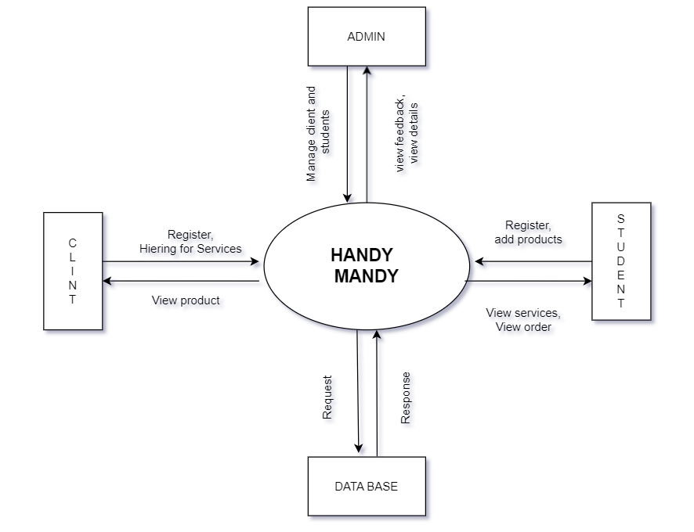

**Data flow diagram:**

Data Flow Diagram is a graphical representation of a system or a portion of the system. It consists of data flows, process, sources and sink and stores all the description using easily understandable symbols. DFD is one of the most important modelling tools. It is used to model the system, components that interact with the system, uses the data and information flows in the system. DFD shows the information moves through the and how it is modified by a series of transformations. It is a graphical technique that depicts information moves from input or output. DFD is also knows as bubble chart or Data Flow Graphs. DFD may be used to represent the system at any level of abstraction. DFD’s may partition into a level that represents increasing information flows and functional details.

Rules Regarding DFD Construction:

A process cannot have only outputs.

A process cannot have only inputs.

The inputs to a process must be sufficient to produce the outputs from the process. All data stores must be connected to at least one process. All data stores must be connected to a source or sink. A data flow can have only one direction of flow. Multiple data flows to and/or from the same process and data store must be shown by separate arrows.

If the exact same data flows to two separate arrows, it should be represented by a forked arrow.

Data cannot flow directly back into the process it has just left. All data flows must be named using a noun phrase.

**DFD Symbols:**

|  |  |  |
| --- | --- | --- |
| **Name** | **Notation** | **Description** |
| **Process** | Shape | A process transforms incoming data flow into outgoing data flow. The processes are shown by named circles. |
| **Datastore** | ShapeShape | Data stores are repositories of data in the system. They are sometimes also referred to as files. |
| **Dataflows** | ShapeShape | Data flows are pipelines through which packets of information flow. Label the arrows with the name of the data that moves through it. |
| **External Entity** | Shape | External entities are objects outside the system with which the system communicates. External Entities are sources and destinations of the system’s inputs and outputs |

**DFD level 1**

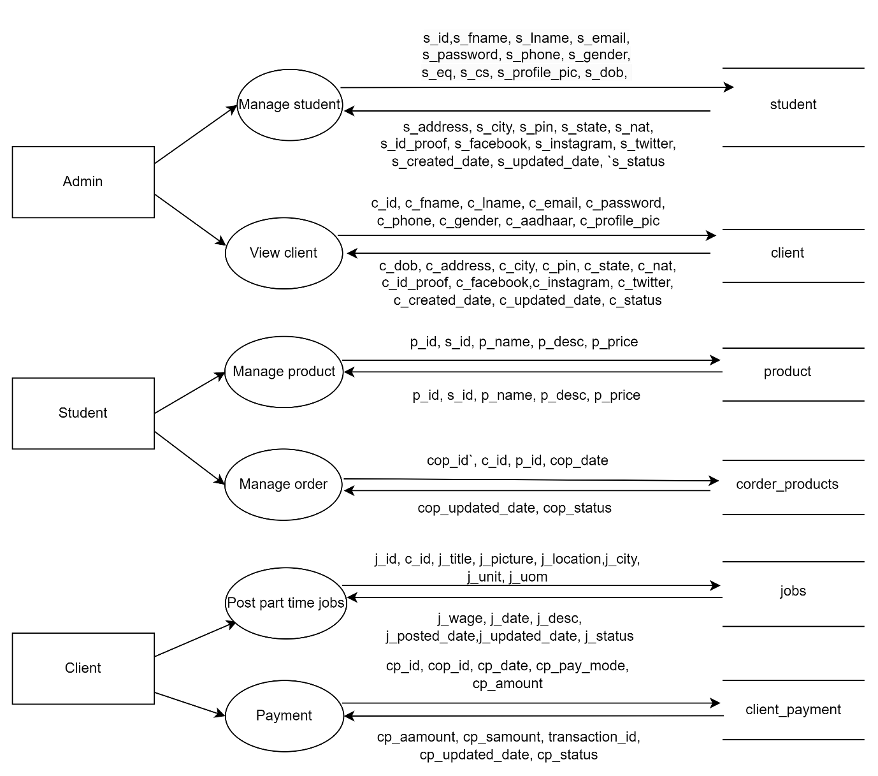

**DFD level 2(ADMIN):**

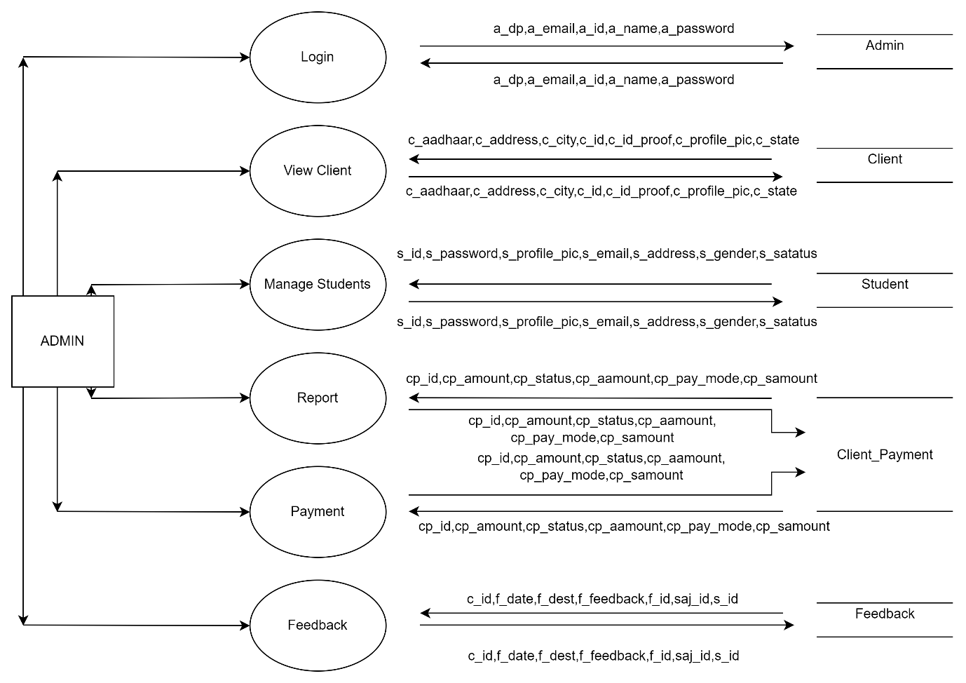

**DFD level 2(Student):**

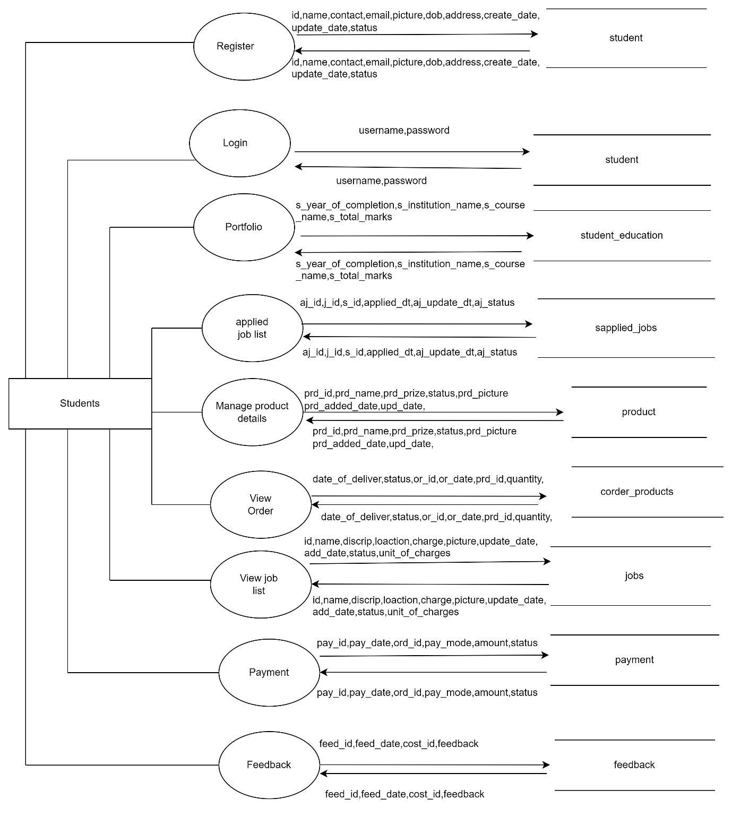

**DFD level 2(Client):**

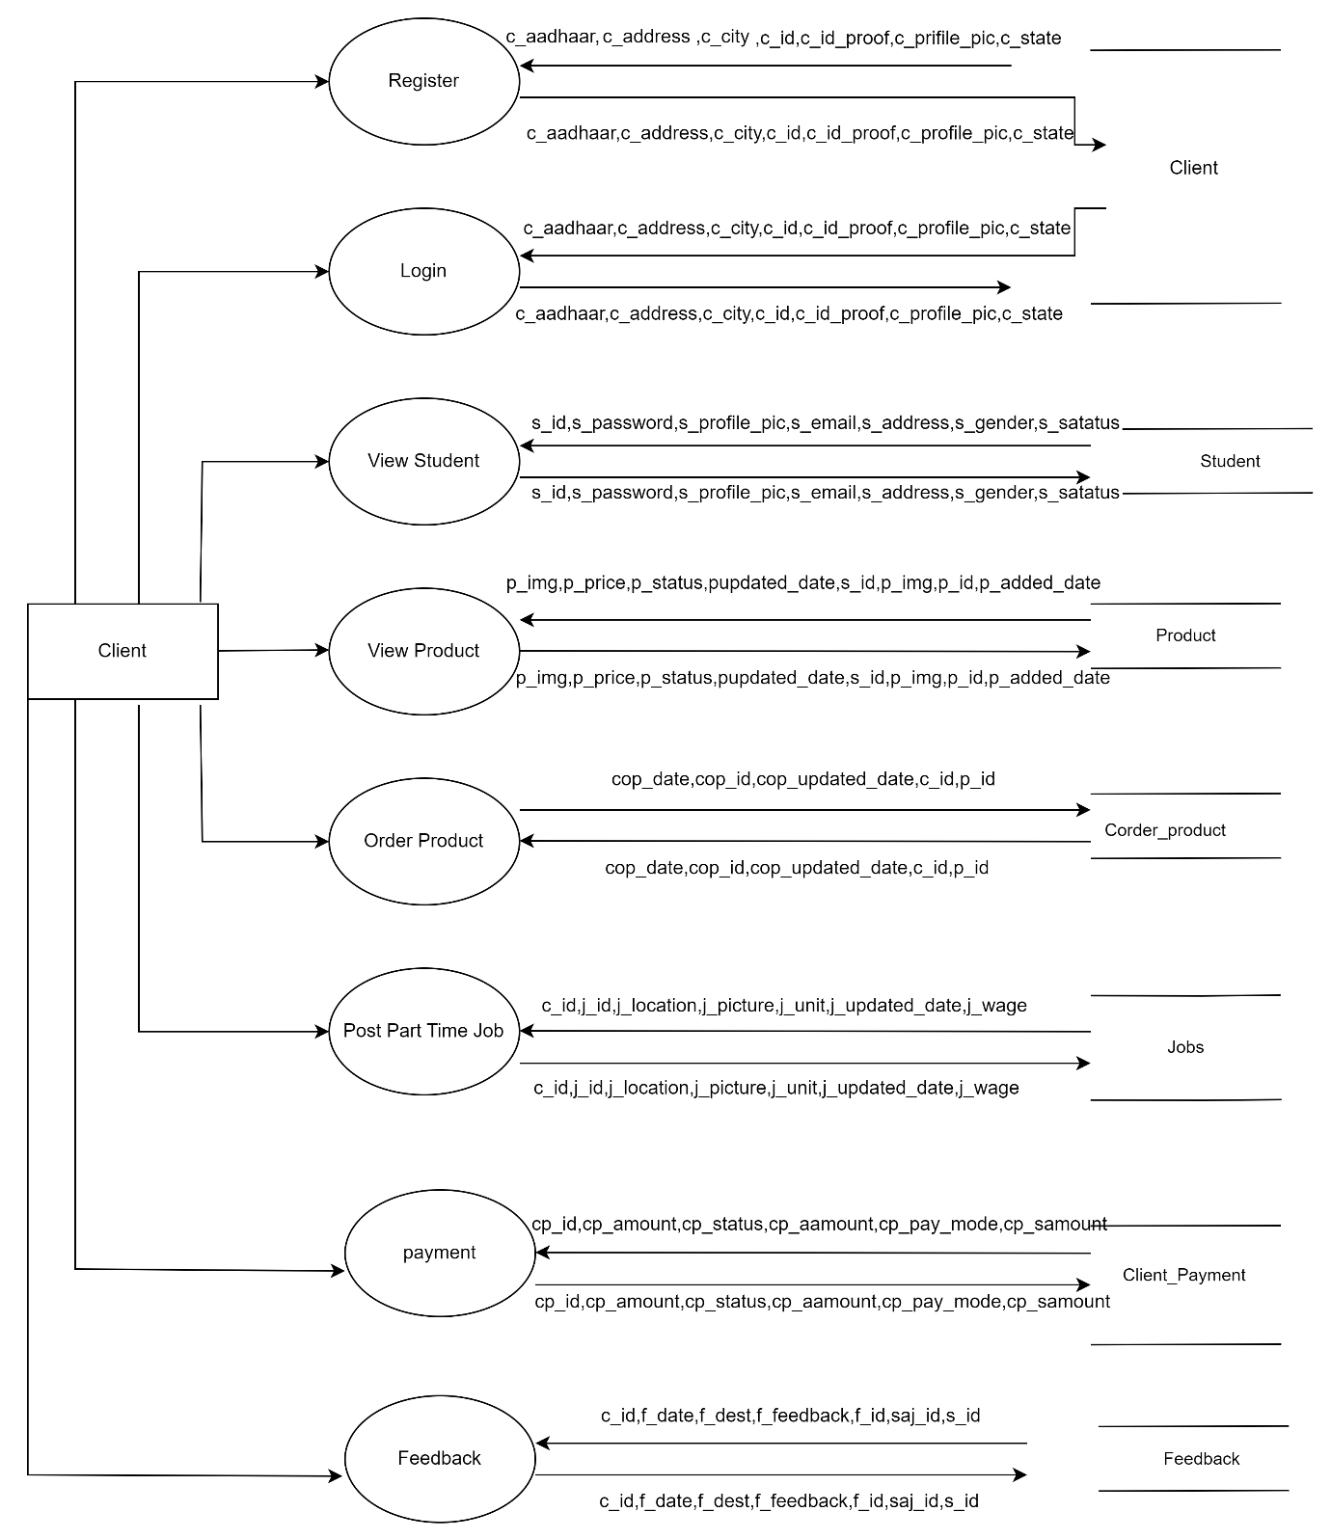

**Entity-Relationship Diagram:**

The basic objective of the ER model representation is an entity which is a “thing” in a real world with an independent existence. Entities are physical items or aggregations of data items that are important to the business we analyse or to the system; we intend to build. An entity represents an object defined within the information system about which you want to store information. Entities are named as singular nouns and are shown in rectangles in an ER-Diagram. Each entity is described by several attributes; individual instances of an entity will have different attribute values.

**ER-Diagram Symbols:**

|  |  |  |
| --- | --- | --- |
| **Name** | **Notation** | **Description** |
| **Entity** | Shape | It may be an object with the physical existence or conceptual existence. It is represented by a Rectangle. |
| **Attribute** | Shape | The properties of the entity can be a attribute. It is represented by a Ellipse. |
| **Relationship** | **Relationship** | Whenever an attribute of one entity refers to another entity, some relationship exists. It is represented by a Diamond. |
| **Link** | Shape | Lines link attributes to entity sets and entity sets to relation. |
| **Key Attribute** | Shape | An entity type usually has an attribute whose values are distinct for each individual entry in the entity set. It is represented by a Underlined word in ellipse. |
| **Cardinality Ratio** | 1. 1:1 2. 1:M 3. M:1 4. M:M | It specifies the maximum number of relationships instances that an entity can participate in. There are four cardinality ratios. |

**ER Diagram:**

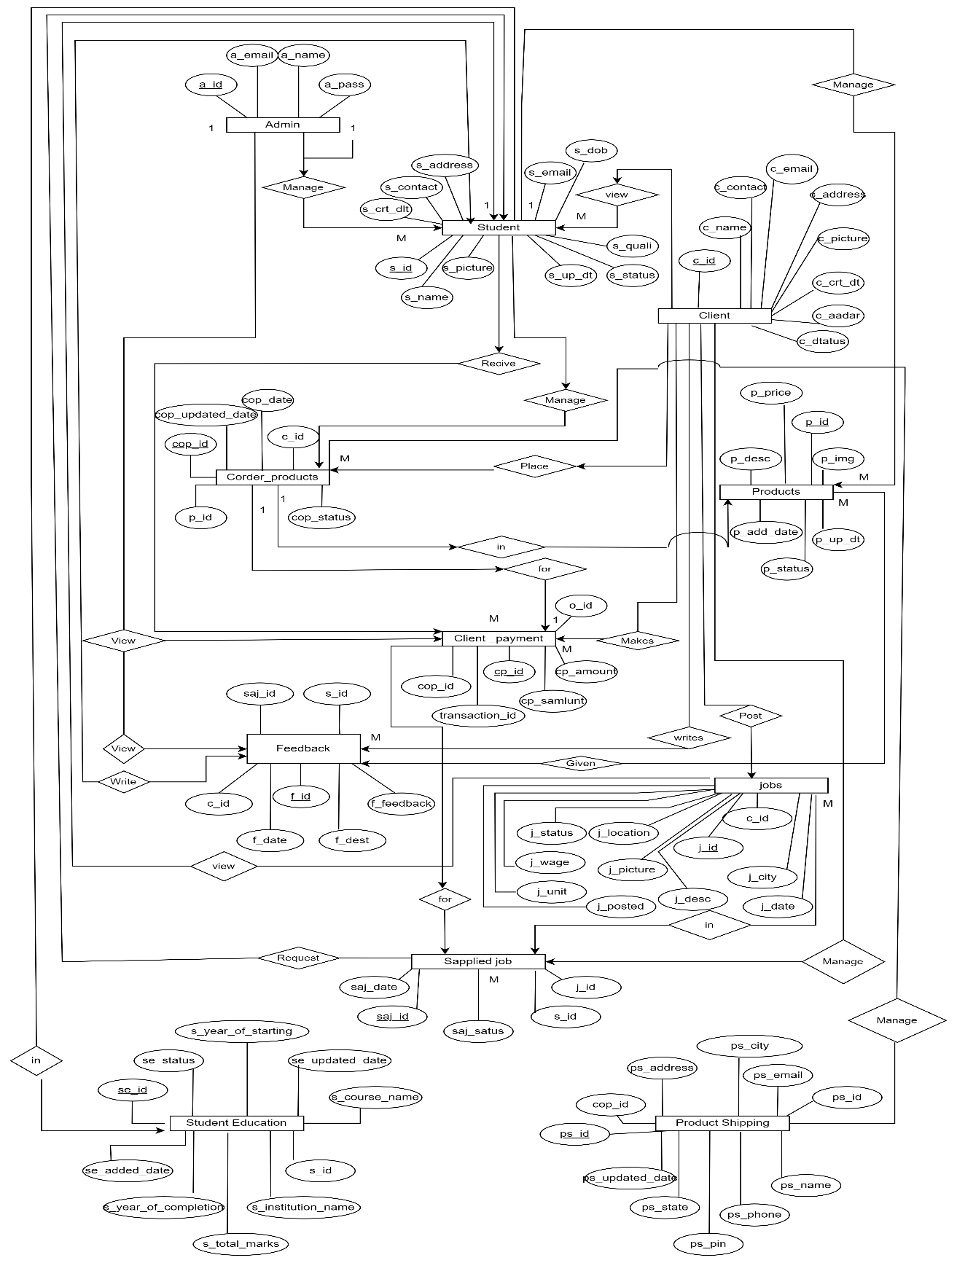

**DATABASE DESIGN**

**INTRODUCTION**

**Database** - A Database is a collection of related data, which can be of any size and complexity. By using the concept of Database, we can easily store and retrieve the data. The major purpose of database is to provide the information, which utilizes with information that the system needs according to its own requirements.

**A Database Administrator** (DBA) is responsible the maintenance, performance, integrity and security of a database. A database consists of a number of interrelated table search table has a number of records which are used to represent real world objects. Each record has a number of fields which are data items used to specify characteristics of the records. A table is a collection of related data held in structure format with in a database. It consists columns and row. A table has specified number of columns, but can have any number of rows. Each row is identified by one or more values appearing in a particular column’s subset. The columns subset which uniquely identifies a row is called the primary key, so by using primary key we can delete or update specified field’s values of the row.

**Database Design** – Database Design is done before building it to meet the needs of end users within a given information system that the database is intended to support. The Database Design defines the needed data and data structures such that a database comprises.

The database is physically implemented using MYSQL.

**The database hms is organized into 11 tables:**

* admin
* client
* client_payment
* corder_products
* feedback
* jobs
* products
* product_shipping
* sapplied_jobs
* student
* student_education

|  |  |  |  |  |
| --- | --- | --- | --- | --- |
| **Attributes** | **Attributes** | **Size** | **Constraint** | **Description** |
| a_id | int | 250 | PRIMARY KEY, NOT NUL | Admin identification |
| a_name | varchar | 500 | NOT NUL | Admin name |
| a_email | varchar | 1200 | NOT NUL | Admin email |
| a_password | varchar | 1200 | NOT NUL | Admin password |
| a_dp | varchar | 1200 | NOT NUL | Admin DP |

* **admin**
* **client**

|  |  |  |  |  |
| --- | --- | --- | --- | --- |
| **Attributes** | **Data Types** | **Size** | **Constraint** | **Description** |
| c_id | int | 11 | PRIMARY KEY, NOT NUL | Client identification |
| c_fname | varchar | 200 | NOT NUL | Client first name |
| c_lname | varchar | 300 | NOT NUL | Client last name |
| c_email | varchar | 400 | NOT NUL | Client email |
| c_password | varchar | 300 | NOT NUL | Client password |
| c_phone | varchar | 200 | NOT NUL | Client contact |
| c_gender | varchar | 400 | NOT NUL | Client gender |
| c_aadhaar | varchar | 200 | NOT NUL | Client Aadhaar |
| c_profile_pic | varchar | 800 | NOT NUL | Client profile picture |
| c_dob | date | - | NOT NUL | Client date of birth |
| c_address | varchar | 400 | NOT NUL | Client address |
| c_city | varchar | 300 | NOT NUL | Client city |
| c_pin | int | 200 | NOT NUL | Client Pin code |
| c_state | varchar | 700 | NOT NUL | Client state |
| c_nat | varchar | 500 | NOT NUL | Client nation |
| c_id_proof | varchar | 800 | NOT NUL | Client id |
| c_facebook | varchar | 1200 | NOT NUL | Client Facebook |
| c_instagram | varchar | 1200 | NOT NUL | Client Instagram |
| c_twitter | varchar | 1200 | NOT NUL | Client Twitter |
| c_picture | varchar | 500 | NOT NUL | Client picture |
| c_created_date | date | - | NOT NUL | Client created date |
| c_updated_date | date | - | NOT NUL | Client updated date |
| c_status | varchar | 500 | NOT NUL | Client status |

* **client_payment**

|  |  |  |  |  |
| --- | --- | --- | --- | --- |
| **Attributes** | **Data Types** | **Size** | **Constraint** | **Description** |
| cp_id | int | 200 | PRIMARY KEY, NOT NUL | Client payment identification |
| cop_id | int | 200 | FOREIGN KEY, NOT NUL | Client order identification |
| cp_date | date | - | NOT NUL | Client payment date |
| cp_pay_mode | varchar | 1200 | NOT NUL | Client payment mode |
| cp_amount | int | 200 | NOT NUL | Client payment amount |
| cp_aamount | int | 200 | NOT NUL | Admin amount |
| cp_samount | int | 200 | NOT NUL | Student amount |
| transaction_id | varchar | 200 | NOT NUL | Transaction identification |
| cp_updated_date | date | - | NOT NUL | Client payment updated date |
| cp_status | varchar | 1200 | NOT NUL | Client payment status |

* **corder_products**

|  |  |  |  |  |
| --- | --- | --- | --- | --- |
| **Attributes** | **Data Types** | **Size** | **Constraint** | **Description** |
| cop_id | int | 200 | PRIMARY KEY, NOT NUL | Client order identification |
| c_id | int | 200 | FOREIGN KEY, NOT NUL | Client identification |
| p_id | int | 200 | FOREIGN KEY, NOT NUL | Product identification |
| cop_date | date | - | NOT NUL | Client order date |
| cop_updated_date | date | - | NOT NUL | Client order updated date |
| cop_status | varchar | 700 | NOT NUL | Client order status |

* **feedback**

|  |  |  |  |  |
| --- | --- | --- | --- | --- |
| **Attributes** | **Data Types** | **Size** | **Constraint** | **Description** |
| f_id | int | 200 | PRIMARY KEY, NOT NUL | Feedback identification |
| s_id | int | 200 | FOREIGN KEY, NOT NUL | Student identification |
| c_id | int | 200 | FOREIGN KEY, NOT NUL | Client identification |
| saj_id | int | 200 | FOREIGN KEY, NOT NUL | Student Applied job identification |
| f_date | date | - | NOT NUL | Feedback date |
| f_feedback | varchar | 1200 | NOT NUL | Feedback |
| f_dest | varchar | 200 | NOT NUL | Feedback destination(a,s) |

* **jobs**

|  |  |  |  |  |
| --- | --- | --- | --- | --- |
| **Attributes** | **Data Types** | **Size** | **Constraint** | **Description** |
| j_id | int | 200 | PRIMARY KEY, NOT NUL | Job identification |
| c_id | int | 200 | FOREIGN KEY, NOT NUL | Client identification |
| j_title | varchar | 1200 | NOT NUL | Job title |
| j_picture | varchar | 1500 | NOT NUL | Job picture |
| j_location | varchar | 1200 | NOT NUL | Job location |
| j_ city | varchar | 1200 | NOT NUL | Job city |
| j_unit | int | 100 | NOT NUL | Job unit |
| j_uom | varchar | 1200 | NOT NUL | Job unit of measure |
| j_wage | int | 200 | NOT NUL | Job wage |
| j_date | date |  | NOT NUL | Job date |
| j_desc | varchar | 1500 | NOT NUL | Job description |
| j_posted_date | date | - | NOT NUL | Job posted date |
| j_updated_date | date | - | NOT NUL | Job updated date |
| j_status | varchar | 500 | NOT NUL | Job status |

* **product**

|  |  |  |  |  |
| --- | --- | --- | --- | --- |
| **Attributes** | **Data Types** | **Size** | **Constraint** | **Description** |
| p_id | int | 200 | PRIMARY KEY, NOT NUL | Product identification |
| s_id | int | 200 | FOREIGN KEY, NOT NUL | Student identification |
| p_name | varchar | 1200 | NOT NUL | Product name |
| p_desc |  |  | NOT NUL | Product description |
| p_price | int | 254 | NOT NUL | Product price |
| p_img | varchar | 3000 |  | Product image |
| p_add_dt | date | - | NOT NUL | Product added date |
| p_up_dt | date | - | NOT NUL | Product updated date |
| p_status | varchar | 400 | NOT NUL | Product status |

* **product_shipping**

|  |  |  |  |  |
| --- | --- | --- | --- | --- |
| **Attributes** | **Data Types** | **Size** | **Constraint** | **Description** |
| ps_id | int | 200 | PRIMARY KEY, NOT NUL | Product shipping identification |
| cop_id | int | 200 | FOREIGN KEY, NOT NUL | Client order identification |
| ps_name | varchar | 1200 | NOT NUL | Product shipping name |
| ps_phone | varchar | 40 | NOT NUL | Product shipping contact |
| ps_email | varchar | 1700 | NOT NUL | Product shipping email |
| ps_address | varchar | 3000 | NOT NUL | Product shipping address |
| ps_city | varchar | 1200 | NOT NUL | Product shipping city |
| ps_pin | int | 50 | NOT NUL | Product shipping Pin code |
| ps_state | varchar | 400 | NOT NUL | Product shipping state |
| ps_updated_date | date | - | NOT NUL | Product shipping updated date |
| ps_status | varchar | 1200 | NOT NUL | Product shipping status |

* **sapplied_jobs**

|  |  |  |  |  |
| --- | --- | --- | --- | --- |
| **Attributes** | **Data Types** | **Size** | **Constraint** | **Description** |
| saj_id | int | 50 | PRIMARY KEY, NOT NUL | Student Applied job identification |
| s_id | int | 200 | FOREIGN KEY, NOT NUL | Student identification |
| j_id | int | 50 | FOREIGN KEY, NOT NUL | Job identification |
| saj_date | date | - | NOT NUL | Student Applied date |
| saj_status | Varchar | 700 | NOT NUL | Student Applied status |

* **student**

|  |  |  |  |  |
| --- | --- | --- | --- | --- |
| **Attributes** | **Data Types** | **Size** | **Constraint** | **Description** |
| s_id | int | 11 | PRIMARY KEY, NOT NUL | Student identification |
| s_fname | varchar | 200 | NOT NUL | Student first name |
| s_lname | varchar | 300 | NOT NUL | Student last name |
| s_email | varchar | 400 | NOT NUL | Student email |
| s_password | varchar | 300 | NOT NUL | Student password |
| s_phone | varchar | 20 | NOT NUL | Student contact |
| s_gender | varchar | 400 | NOT NUL | Student gender |
| s_eq | varchar | 300 | NOT NUL | Student education qualification |
| s_cs | varchar | 300 | NOT NUL | Student course |
| s_profile_pic | varchar | 200 | NOT NUL | Student profile picture |
| s_dob | date | - | NOT NUL | Student date of birth |
| s_address | varchar | 400 | NOT NUL | Student address |
| s_city | varchar | 300 | NOT NUL | Student city |
| s_pin | varchar | 200 | NOT NUL | Student Pin code |
| s_state | varchar | 200 | NOT NUL | Student state |
| s_nat | varchar | 700 | NOT NUL | Student nation |
| s_id_proof | varchar | 800 | NOT NUL | Student ID card |
| s_facebook | varchar | 1200 | NOT NUL | Student Facebook |
| s_instagram | varchar | 1200 | NOT NUL | Student Instagram |
| s_twitter | varchar | 1200 | NOT NUL | Student Twitter |
| s_created_date | date | - | NOT NUL | Student created date |
| s_updated_date | date | - | NOT NUL | Student updated date |
| s_status | varchar | 800 | NOT NUL | Student status |

* **student_education**

|  |  |  |  |  |
| --- | --- | --- | --- | --- |
| **Attributes** | **Data Types** | **Size** | **Constraint** | **Description** |
| se_id | int | 200 | PRIMARY KEY, NOT NUL | Student education identification |
| s_id | int | 200 | FOREIGN KEY, NOT NUL | Student identification |
| s_institution_name | varchar | 1200 | NOT NUL | Student institution name |
| s_course_name | varchar | 1200 | NOT NUL | Student course name |
| s_year_of_starting | year | 4 | NOT NUL | Student year of starting |
| s_year_of_completion | year | 4 | NOT NUL | Student year of completion |
| s_total_marks | varchar | 40 | NOT NUL | Student total marks |
| se_added_date | date | - | NOT NUL | Student education added date |
| se_updated_date | date | - | NOT NUL | Student education updated date |
| se_status | varchar | 1200 | NOT NUL | Student education status |

**SCHEMA DIAGRAM**

|  |
| --- |
| **product_shipping** |
| ps_id |
| cop_id |
| ps_name |
| ps_phone |
| ps_email |
| ps_address |
| ps_city |
| ps_pin |
| ps_state |
| ps_updated_date |
| ps_status |

|  |
| --- |
| **client_payment** |
| cp_id |
| cop_id |
| cp_date |
| cp_pay_mode |
| cp_amount |
| cp_aamount |
| cp_samount |
| transaction_id |
| cp_updated_date |
| cp_status |

|  |
| --- |
| **corder_products** |
| cop_id |
| c_id |
| p_id |
| cop_date |
| cop_updated_date |
| cop_status |

|  |
| --- |
| **product** |
| p_id |
| s_id |
| p_name |
| p_desc |
| p_price |
| p_img |
| p_add_dt |
| p_up_dt |
| p_status |

|  |
| --- |
| **client** |
| c_id |
| c_fname |
| c_lname |
| c_email |
| c_password |
| c_phone |
| c_gender |
| c_aadhaar |
| c_profile_pic |
| c_dob |
| c_address |
| c_city |
| c_pin |
| c_state |
| c_nat |
| c_id_proof |
| c_facebook |
| c_instagram |
| c_twitter |
| c_picture |
| c_created_date |
| c_updated_date |
| c_status |

|  |
| --- |
| **student_education** |
| se_id |
| s_id |
| s_institution_name |
| s_course_name |
| s_year_of_starting |
| s_year_of_completion |
| s_total_marks |
| se_added_date |
| se_updated_date |
| se_status |

|  |
| --- |
| **feedback** |
| f_id |
| s_id |
| c_id |
| saj_id |
| f_date |
| f_feedback |
| f_dest |

|  |
| --- |
| **jobs** |
| j_id |
| c_id |
| j_title |
| j_picture |
| j_location |
| j_ city |
| j_unit |
| j_uom |
| j_wage |
| j_date |
| j_desc |
| j_posted_date |
| j_updated_date |
| j_status |

|  |
| --- |
| **Student** |
| s_id |
| s_fname |
| s_lname |
| s_email |
| s_password |
| s_phone |
| s_gender |
| s_eq |
| s_cs |
| s_profile_pic |
| s_dob |
| s_address |
| s_city |
| s_pin |
| s_state |
| s_nat |
| s_id_proof |
| s_facebook |
| s_instagram |
| s_twitter |
| s_created_date |
| s_updated_date |
| s_status |

|  |
| --- |
| **sapplied_jobs** |
| saj_id |
| s_id |
| j_id |
| saj_date |
| saj_status |

­­

**DETAILED DESIGN**

**INTRODUCTION**

The purpose of the design phase is to plan a solution of the problem specified by the requirements document. This phase is the first step in moving from the problem domain to the solution domain. In other words, starting with what is needed; design takes us towards how to satisfy the needs. The design of the system is perhaps the most critical factor affecting the quality of the software; it has a major impact on the later phases, particularly testing and maintenance.

The design activity often results in three separate outputs- Architecture Design, High Level Design and Detailed Design. Architecture focuses on looking at a system as a combination of many different components, and how they interact with each other to produce the desired results. The High-Level Design identifies the modules that should be built for developing the system and the specifications of these modules. At the end of system design all the major data structures, file formats, output formats etc., are also fixed. In detailed design, the internal logic of each of the modules are specified.

The design process for the software systems often has two levels. At the first level, the focus is on deciding which modules are needed for the system, the specifications of these modules and how the modules should be interconnected. This is what is called the System Design or the Top-Level Design. In the second level, the internal design of the modules, or how the specifications of the module can be satisfied is decided. This design level is often called Detailed Design. Detailed design essentially expands the system design to contain a

more detailed description of the processing logic and data structures so that the design is sufficiently complete for coding.

**APPLICABLE DOCUMENT**

The Detailed Design refines the System Design document hence the first applicable document here is system design. We also refer the data structures. Hence, the second applicable document is database design.

**STRUCTURE OF THE SOFTWARE PACKAGE**

The functional components identified during the system design are listed here:

Functional Component 1 : Admin

Functional Component 2 : Student

Functional Component 3 : Client

**MODULAR DECOMPOSITION OF MODULES**

* **Login Details**: a username and password must be entered to login to the page.
* Input: username, password.
* Output: the main page for the user is displayed
* Processing: the system checks if the user has registered. The registered user can login successfully, else the user has to register first.
* **Settings**: this allows the admin to change the password.
* Input: inserting new password and reconfirming the password.
* Output: a notification will be displayed saying that the password has been changed,
* Processing: the system checks if the user has registered. The registered user can login successfully, else the user must register first.
* **Register Details:** The necessary and personal details will be added. For students they must add an id picture to verify.
* Input: details of students and clients will be needed.
* Output: the user is registered into the application.
* Processing: the system checks for the validity of the input. registration is successful for valid information, else unsuccessful.
* **Manage users:** This module allows the information of the students and clients to be displayed.
* Input: displays the details of the students and clients that were filled out in the form. The admin can either approve or reject the users.
* Output: the details of the students and clients will be displayed.
* Processing: it will generate the student and client’s information.
* **Product details:** this module allows the students to display and price the product that they have created.
* Input: displays details of the product sold by the students
* Output: the details of products will be displayed.
* Processing: it will generate product information.
* **Add products:** this module allows the students to edit the product details.
* Input: adding details of the product sold by the students
* Output: the details of products will be displayed.
* Processing: it will generate product information.
* **Order details**: this module allows the students to display and price the product that they have created.
* Input: adding details of order of the product sold by the students.
* Output: the details of order of a product of will be displayed.
* Processing: it will generate the order information.
* **Payment:** this is receiving the money via through online.
* Input: Bill Number, Amount, Payment Date.
* Output: Payment details are stored
* Processing: For online payment the system checks for the validity of payment.
* **Student details:** This module allows the information of the students to be displayed. This allows the student to display their id picture and create a portfolio.
* Input: displays the details of the students that was filled out in the form.
* Output: the details of the students will be displayed.
* Processing: it will generate the student’s information.
* **Applied job list:** This module allows the students to select the job that they want to apply from the clients.
* Input: displays the selection of the job and its details.
* Output: the details of the job details will be displayed.
* Processing: it will generate the job’s information.
* **Client details:** this module allows the information of the clients to be displayed and edited.
* Input: displays and edits the details of the clients that was filled out in the form.
* Output: the details of the clients will be displayed.
* Processing: it will generate the client’s information.
* **Job list:** this module allows the information of the jobs details to be displayed of one client.
* Input: displays and edits the details of the clients and students that was filled out in the form.
* Output: displays the jobs being offered by the clients.
* Processing: it will generate the jobs descriptions.
* **Add Job list:** this module allows the client to add job details for thee students to see.
* Input: displays the details of the job for the client to fill in.
* Output: displays the jobs being offered by the clients.
* Processing: it will generate the jobs information to the student.
* **View applicants:** this module allows the client to choose a student for the job.
* Input: displays the student’s detail where the client can either reject or approve them for the job.
* Output: displays the jobs description as well as the students.
* Processing: it will generate the jobs and students’ information.
* **Contact us** allows the users to contact the admin for any errors or issues.
* Input: contact information will be displayed of the admin.
* Output: the details will be publicly displayed.
* Processing: it will navigate to calls or emails and generate information.
* **Feedback:** this module allows the user to collect, analyze, and display feedback submitted by users.
* Input: User must submit reviews in the form of text, images, or videos.
* Output: The system should display user reviews.
* Processing: The system should analyze user allows to detect fake or spam reviews feedbacks.
* **Logout** this module allows the current user to end the login session.
* Input: user must click on logout button.
* Output: Logout will go back to the home.
* Processing: it will generate homepage web application.

**STRUCTURE CHART**

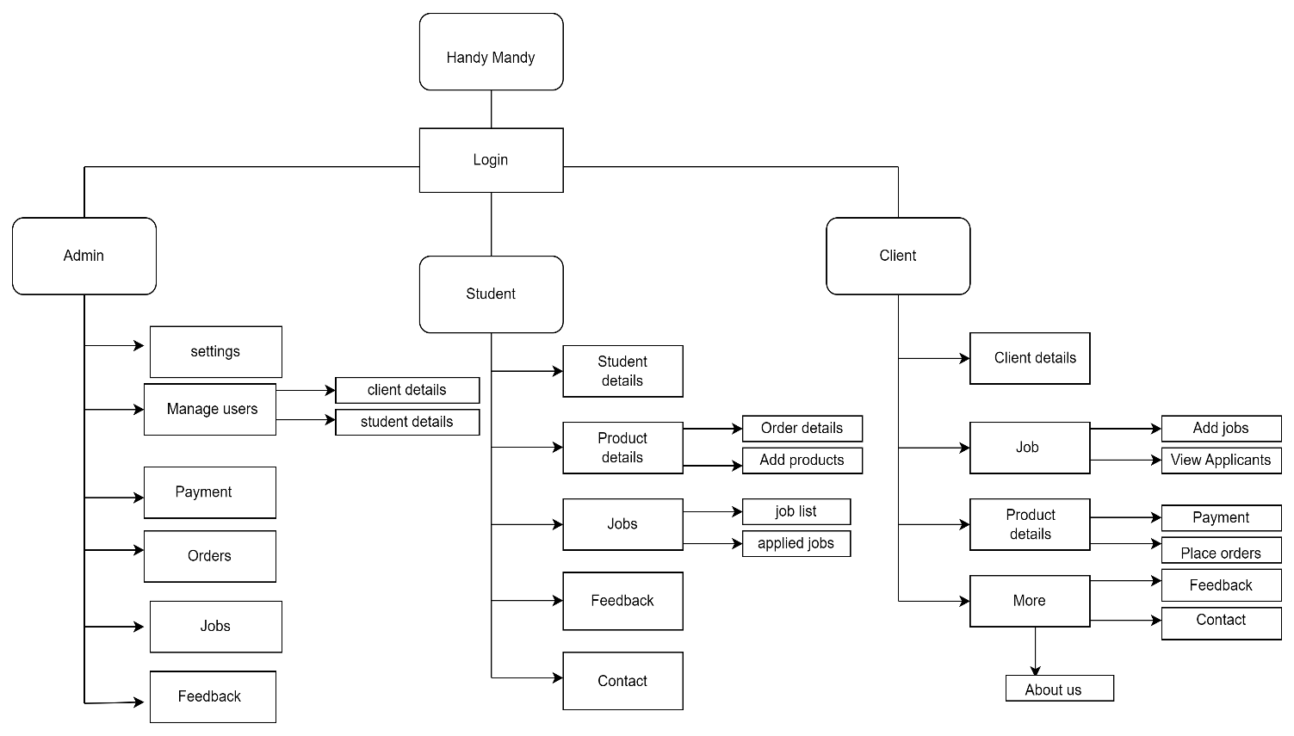

**CODING**

* **Admin**
* **Addelete_client.php**

<?php

define('DIR','../../');

require_once DIR . '/config.php';

$admin = new Admin();

$c_id = $_GET['c_id'];

$stmt = $admin->cud("DELETE FROM `client` where `c_id` = '$c_id'","deleted");

echo "<script>alert('Client record deleted Successfully');window.location='../view_clients.php';

</script>";

?>

* **Aupdate_student.php**

<?php

// define('DIR','../../');

// require_once DIR . '/config.php';

include '../../config.php';

$control = new Controller();

$admin=new Admin();

if (isset($_POST['update'])) {

$id=$_POST['s_id'];

$status=$_POST['update_sstatus'];

$stmt=$admin->ret("UPDATE `student` SET `s_status`='$status' WHERE `s_id`='$id'");

echo "<script>alert('Student profile has been approved successfully...');window.location='../view_students.php';</script>";

}

if (isset($_POST['cupdate'])) {

$idd=$_POST['c_id'];

$cstatus=$_POST['update_cstatus'];

$stmt=$admin->ret("UPDATE `client` SET `c_status`='$cstatus' WHERE `c_id`='$idd'");

echo "<script>alert('Client profile has been approved successfully...');window.location='../view_clients.php';</script>";

}

?>

* **View_clients.php**

<?php

include '../config.php';

$admin=new Admin();

if(!isset($_SESSION['a_id'])){

header('Location:index.php');

}

$aid=$_SESSION['a_id'];

?>

<!DOCTYPE html>

<html lang="en">

<head>

<!-- Required meta tags -->

<meta charset="utf-8">

<meta name="viewport" content="width=device-width, initial-scale=1, shrink-to-fit=no">

<title>Admin | Clients</title>

<!-- plugins:css -->

<link rel="stylesheet" href="assets/vendors/mdi/css/materialdesignicons.min.css">

<link rel="stylesheet" href="assets/vendors/css/vendor.bundle.base.css">

<!-- endinject -->

<!-- Plugin css for this page -->

<link rel="stylesheet" href="assets/vendors/jvectormap/jquery-jvectormap.css">

<link rel="stylesheet" href="assets/vendors/flag-icon-css/css/flag-icon.min.css">

<link rel="stylesheet" href="assets/vendors/owl-carousel-2/owl.carousel.min.css">

<link rel="stylesheet" href="assets/vendors/owl-carousel-2/owl.theme.default.min.css">

<!-- End plugin css for this page -->

<!-- inject:css -->

<!-- endinject -->

<!-- Layout styles -->

<link rel="stylesheet" href="assets/css/style.css">

<!-- End layout styles -->

<link rel="shortcut icon" href="assets/images/favicon.png" />

</head>

<body>

<div class="container-scroller">

<!-- partial:partials/_sidebar.html -->

<?php include 'sidebar.php';

?>

<!-- partial -->

<?php include 'header.php';

?>

<!-- partial -->

<div class="main-panel">

<div class="content-wrapper">

<div class="row ">

<div class="col-12 grid-margin">

<div class="card">

<div class="card-body">

<h4 class="card-title">Clients</h4>

<div class="table-responsive">

<table class="table">

<thead>

<tr>

<th> SL No</th>

<th> Client Name </th>

<th> Contact Number </th>

<th> Email address </th>

<th> Address </th>

<th> Status </th>

<th> View </th>

<th> Delete </th>

</tr>

</thead>

<tbody>

<?php

$i=1;

$stmtt=$admin->ret("SELECT * FROM `client`");

while($row=$stmtt->fetch(PDO::FETCH_ASSOC)){

?>

<tr>

<td><?php echo $i++; ?></td>

<td>

<img src="../client/controller/<?php echo $row['c_profile_pic']; ?>" alt="image" />

<span class="pl-2"><?php echo $row['c_fname']; ?> <?php echo $row['c_lname']; ?></span>

</td>

<td> <?php echo $row['c_phone']; ?> </td>

<td> <?php echo $row['c_email']; ?> </td>

<td> <?php echo $row['c_address']; ?>, <?php echo $row['c_city']; ?> </td>

<?php if ($row['c_status']=="created") { ?>

<td>

<div class="badge badge-outline-primary">Created</div>

</td>

<?php } else if($row['c_status']=="updated"){?>

<td>

<div class="badge badge-outline-success">Updated</div>

</td>

<?php } else if($row['c_status']=="approved"){?>

<td>

<div class="badge badge-outline-warning">Approved</div>

</td>

<?php } else if($row['c_status']=="rejected"){?>

<td>

<div class="badge badge-outline-danger">Rejected</div>

</td>

<?php } ?>

<td>

<a title="view/update record?" href="update_client.php?c_id=<?php echo $row['c_id'];?>">

<i class="mdi mdi-open-in-new text-white" style="font-size: 30px;"></i>

</a>

</td>

<td>

<a title="delete record?" href="controller/adelete_client.php?c_id=<?php echo $row['c_id'];?>">

<i class="mdi mdi-delete-forever text-danger" style="font-size:30px"></i>

</a>

</td>

</tr>

<?php } ?>

</tbody>

</table>

</div>

</div>

</div>

</div>

</div>

<!-- content-wrapper ends -->

<!-- partial:partials/_footer.html -->

<!-- <footer class="footer">

<div class="d-sm-flex justify-content-center justify-content-sm-between">

<span class="text-muted d-block text-center text-sm-left d-sm-inline-block">Copyright © bootstrapdash.com 2020</span>

<span class="float-none float-sm-right d-block mt-1 mt-sm-0 text-center"> Free <a href="https://www.bootstrapdash.com/bootstrap-admin-template/" target="_blank">Bootstrap admin templates</a> from Bootstrapdash.com</span>

</div>

</footer> -->

<!-- partial -->

</div>

<!-- main-panel ends -->

</div>

<!-- page-body-wrapper ends -->

</div>

<!-- container-scroller -->

<!-- plugins:js -->

<script src="assets/vendors/js/vendor.bundle.base.js"></script>

<!-- endinject -->

<!-- Plugin js for this page -->

<script src="assets/vendors/chart.js/Chart.min.js"></script>

<script src="assets/vendors/progressbar.js/progressbar.min.js"></script>

<script src="assets/vendors/jvectormap/jquery-jvectormap.min.js"></script>

<script src="assets/vendors/jvectormap/jquery-jvectormap-world-mill-en.js"></script>

<script src="assets/vendors/owl-carousel-2/owl.carousel.min.js"></script>

<!-- End plugin js for this page -->

<!-- inject:js -->

<script src="assets/js/off-canvas.js"></script>

<script src="assets/js/hoverable-collapse.js"></script>

<script src="assets/js/misc.js"></script>

<script src="assets/js/settings.js"></script>

<script src="assets/js/todolist.js"></script>

<!-- endinject -->

<!-- Custom js for this page -->

<script src="assets/js/dashboard.js"></script>

<!-- End custom js for this page -->

</body>

</html>

* **Index.php**

<!DOCTYPE html>

<html lang="en">

<head>

<!-- Required meta tags -->

<meta charset="utf-8">

<meta name="viewport" content="width=device-width, initial-scale=1, shrink-to-fit=no">

<title>Admin | Login</title>

<!-- plugins:css -->

<link rel="stylesheet" href="assets/vendors/mdi/css/materialdesignicons.min.css">

<link rel="stylesheet" href="assets/vendors/css/vendor.bundle.base.css">

<!-- endinject -->

<!-- Plugin css for this page -->

<!-- End plugin css for this page -->

<!-- inject:css -->

<!-- endinject -->

<!-- Layout styles -->

<link rel="stylesheet" href="assets/css/style.css">

<!-- End layout styles -->

<link rel="shortcut icon" href="assets/images/favicon.png" />

</head>

<body>

<div class="container-scroller">

<div class="container-fluid page-body-wrapper full-page-wrapper">

<div class="row w-100 m-0">

<div class="content-wrapper full-page-wrapper d-flex align-items-center auth login-bg">

<div class="card col-lg-4 mx-auto" style="background-color:#000000cc;" >

<div class="card-body px-5 py-5">

<h3 class="card-title text-left mb-3">Admin Login</h3>

<form method="POST" action="controller/alogin.php">

<div class="form-group">

<label>Email ID</label>

<input type="email" class="form-control p_input" name="aemail" title="enter admin email id" required>

</div>

<div class="form-group">

<label>Password</label>

<input type="password" class="form-control p_input" name="apassword" title="enter admin password" required>

</div>

<div class="text-center mt-3">

<button type="submit" class="btn btn-primary btn-block enter-btn mt-3" name="alogin">Login</button>

</div>

</form>

</div>

</div>

</div>

<!-- content-wrapper ends -->

</div>

<!-- row ends -->

</div>

<!-- page-body-wrapper ends -->

</div>

<!-- container-scroller -->

<!-- plugins:js -->

<script src="../../assets/vendors/js/vendor.bundle.base.js"></script>

<!-- endinject -->

<!-- Plugin js for this page -->

<!-- End plugin js for this page -->

<!-- inject:js -->

<script src="../../assets/js/off-canvas.js"></script>

<script src="../../assets/js/hoverable-collapse.js"></script>

<script src="../../assets/js/misc.js"></script>

<script src="../../assets/js/settings.js"></script>

<script src="../../assets/js/todolist.js"></script>

<!-- endinject -->

</body>

</html>

* **Update_student.php**

<?php

include '../config.php';

$admin=new Admin();

if(!isset($_SESSION['a_id'])){

header('Location:index.php');

}

$aid=$_SESSION['a_id'];

$s_id=$_GET['s_id'];

$stmt9=$admin->ret("SELECT * FROM `student` WHERE `s_id`='$s_id'");

$row0=$stmt9->fetch(PDO::FETCH_ASSOC);

?>

<!DOCTYPE html>

<html lang="en">

<head>

<!-- Required meta tags -->

<meta charset="utf-8">

<meta name="viewport" content="width=device-width, initial-scale=1, shrink-to-fit=no">

<title>Admin | View Student</title>

<!-- plugins:css -->

<link rel="stylesheet" href="assets/vendors/mdi/css/materialdesignicons.min.css">

<link rel="stylesheet" href="assets/vendors/css/vendor.bundle.base.css">

<!-- endinject -->

<!-- Plugin css for this page -->

<link rel="stylesheet" href="assets/vendors/jvectormap/jquery-jvectormap.css">

<link rel="stylesheet" href="assets/vendors/flag-icon-css/css/flag-icon.min.css">

<link rel="stylesheet" href="assets/vendors/owl-carousel-2/owl.carousel.min.css">

<link rel="stylesheet" href="assets/vendors/owl-carousel-2/owl.theme.default.min.css">

<!-- End plugin css for this page -->

<!-- inject:css -->

<!-- endinject -->

<!-- Layout styles -->

<link rel="stylesheet" href="assets/css/style.css">

<!-- End layout styles -->

<link rel="shortcut icon" href="assets/images/favicon.png" />

<!-- Favicon -->

<link href="img/favicon.ico" rel="icon">

<!-- Google Web Fonts -->

<link rel="preconnect" href="https://fonts.googleapis.com">

<link rel="preconnect" href="https://fonts.gstatic.com" crossorigin>

<link href="https://fonts.googleapis.com/css2?family=Heebo:wght@400;500;600&family=Inter:wght@700;800&display=swap" rel="stylesheet">

<!-- Icon Font Stylesheet -->

<link href="https://cdnjs.cloudflare.com/ajax/libs/font-awesome/5.10.0/css/all.min.css" rel="stylesheet">

<link href="https://cdn.jsdelivr.net/npm/bootstrap-icons@1.4.1/font/bootstrap-icons.css" rel="stylesheet">

<!-- Libraries Stylesheet -->

<link href="lib/animate/animate.min.css" rel="stylesheet">

<link href="lib/owlcarousel/assets/owl.carousel.min.css" rel="stylesheet">

<!-- Customized Bootstrap Stylesheet -->

<link href="css/bootstrap.min.css" rel="stylesheet">

<!-- Template Stylesheet -->

<link href="css/stylee.css" rel="stylesheet">

<link href="css/styyle.css" rel="stylesheet">

</head>

<body>

<div class="container-scroller">

<!-- partial:partials/_sidebar.html -->

<?php include 'sidebar.php';

?>

<!-- partial -->

<?php include 'header.php';

?>

<!-- partial -->

<div class="main-panel">

<div class="content-wrapper">

<div class="row ">

<div class="col-12 grid-margin d-flex" style="display:flex;flex-direction: row;flex-wrap: wrap;gap: 50px;">

<div class="card col-lg-4">

<div class="card-body">

<div class="d-flex flex-column align-items-center text-center">

<img alt="Admin" class="rounded-circle" width="150" src="../student/controller/<?php echo $row0['s_profile_pic']; ?>" data-bs-toggle="modal" data-bs-target="#exampleModal2" >

<div class="mt-3">

<h4><?php echo $row0['s_fname']; ?><br><?php echo $row0['s_lname']; ?></h4>

<!-- <p class="text-secondary mb-1">Full Stack Developer</p> -->

<p class="text-muted font-size-sm"><?php echo $row0['s_address']; ?> - <?php echo $row0['s_city']; ?><br>

<?php echo $row0['s_pin']; ?> - <?php echo $row0['s_state']; ?></p>

</div>

</div>

</div>

</div>

<div class="card col-lg-6">

<div class="text-center bg-success">

<h5 class=" text-white mt-2">Social Media Accounts</h5>

</div>

<ul class="list-group list-group-flush">

<li class="list-group-item d-flex justify-content-between align-items-center flex-wrap">

<h6 class="mb-0">

<i class="mdi mdi-email-outline text-black" style="font-size:26px"></i>

</svg>Email</h6>

<span class="text-black"><?php echo $row0['s_email']; ?></span>

</li>

<li class="list-group-item d-flex justify-content-between align-items-center flex-wrap">

<h6 class="mb-0"><svg xmlns="http://www.w3.org/2000/svg" width="24" height="24" viewBox="0 0 24 24" fill="none" stroke="currentColor" stroke-width="2" stroke-linecap="round" stroke-linejoin="round" class="feather feather-twitter mr-2 icon-inline text-info"><path d="M23 3a10.9 10.9 0 0 1-3.14 1.53 4.48 4.48 0 0 0-7.86 3v1A10.66 10.66 0 0 1 3 4s-4 9 5 13a11.64 11.64 0 0 1-7 2c9 5 20 0 20-11.5a4.5 4.5 0 0 0-.08-.83A7.72 7.72 0 0 0 23 3z"></path></svg>Twitter</h6>

<span class="text-black"><?php echo $row0['s_twitter']; ?></span>

</li>

<li class="list-group-item d-flex justify-content-between align-items-center flex-wrap">

<h6 class="mb-0"><svg xmlns="http://www.w3.org/2000/svg" width="24" height="24" viewBox="0 0 24 24" fill="none" stroke="currentColor" stroke-width="2" stroke-linecap="round" stroke-linejoin="round" class="feather feather-instagram mr-2 icon-inline text-danger"><rect x="2" y="2" width="20" height="20" rx="5" ry="5"></rect><path d="M16 11.37A4 4 0 1 1 12.63 8 4 4 0 0 1 16 11.37z"></path><line x1="17.5" y1="6.5" x2="17.51" y2="6.5"></line></svg>Instagram</h6>

<span class="text-black"><?php echo $row0['s_instagram']; ?></span>

</li>

<li class="list-group-item d-flex justify-content-between align-items-center flex-wrap">

<h6 class="mb-0"><svg xmlns="http://www.w3.org/2000/svg" width="24" height="24" viewBox="0 0 24 24" fill="none" stroke="currentColor" stroke-width="2" stroke-linecap="round" stroke-linejoin="round" class="feather feather-facebook mr-2 icon-inline text-primary"><path d="M18 2h-3a5 5 0 0 0-5 5v3H7v4h3v8h4v-8h3l1-4h-4V7a1 1 0 0 1 1-1h3z"></path></svg>Facebook</h6>

<span class="text-black"><?php echo $row0['s_facebook']; ?></span>

</li>

</ul>

</div>

<div class="col-sm-12 mb-3">

<div class="card col-lg-4">

<div class="card-body d-flex flex-column align-items-center text-center">

<h6 class="d-flex align-items-center mb-3 d-flex flex-column align-items-center text-center"><i class="material-icons text-info mr-2">ID Proof</i></h6>

<img style="width: 15vw" src="../student/controller/<?php echo $row0['s_id_proof']; ?>" alt="abc" width="150" data-bs-toggle="modal" data-bs-target="#exampleModal">

<!--ID Modal -->

<div class="modal fade" id="exampleModal" tabindex="-1" aria-labelledby="exampleModalLabel" aria-hidden="true">

<div class="modal-dialog modal-md">

<div class="modal-content">

<div class="modal-header bg-dark">

<h1 class="modal-title fs-5 text-white" id="exampleModalLabel">Student ID Proof</h1>

<button type="button" class="btn-close bg-light" data-bs-dismiss="modal" aria-label="Close"></button>

</div>

<div class="modal-body d-flex flex-column align-items-center text-center">

<img style="width: 30vw" src="controller/<?php echo $row0['s_id_proof']; ?>" alt="abc" width="150">

</div>

</div>

</div>

</div>

<!--dp Modal -->

<div class="modal fade" id="exampleModal2" tabindex="-1" aria-labelledby="exampleModalLabel" aria-hidden="true">

<div class="modal-dialog modal-md">

<div class="modal-content">

<div class="modal-header bg-dark">

<h1 class="modal-title fs-5 text-white" id="exampleModalLabel">Student Profile Picture</h1>

<button type="button" class="btn-close bg-light" data-bs-dismiss="modal" aria-label="Close"></button>

</div>

<div class="modal-body d-flex flex-column align-items-center text-center">

<img style="width: 30vw" src="controller/<?php echo $row0['s_profile_pic']; ?>" alt="abc" width="150">

</div>

</div>

</div>

</div>

</div>

</div>

</div>

</div>

<div class="col-md-8">

<div class="card mb-3">

<div class="card-body">

<div class="row">

<div class="col-sm-3">

<h6 class="mb-0">Full Name</h6>

</div>

<div class="col-sm-9 text-secondary">

<?php echo $row0['s_fname']; ?>&nbsp;<?php echo $row0['s_lname']; ?>

</div>

</div>

<hr>

<div class="row">

<div class="col-sm-3">

<h6 class="mb-0">Email</h6>

</div>

<div class="col-sm-9 text-secondary">

<?php echo $row0['s_email']; ?>

</div>

</div>

<hr>

<div class="row">

<div class="col-sm-3">

<h6 class="mb-0">Mobile</h6>

</div>

<div class="col-sm-9 text-secondary">

<?php echo $row0['s_phone']; ?>

</div>

</div>

<hr>

<div class="row">

<div class="col-sm-3">

<h6 class="mb-0">Address</h6>

</div>

<div class="col-sm-9 text-secondary">

<?php echo $row0['s_address']; ?> - <?php echo $row0['s_city']; ?>,&nbsp;

<?php echo $row0['s_pin']; ?> - <?php echo $row0['s_state']; ?>

</div>

</div>

</div>

</div>

<div class="row gutters-sm">

<div class="col-sm-16 mb-3">

<div class="card h-100">

<div class="card-body">

<h6 class="d-flex align-items-center mb-3"><i class="material-icons text-info mr-2">Education&nbsp;|</i>&nbsp;History</h6>

<table class="table table-hover">

<thead>

<tr>

<th scope="col">SL No</th>

<th scope="col">Instistution</th>

<th scope="col">Course</th>

<th scope="col">Year of starting</th>

<th scope="col">Year of completion</th>

<th scope="col">Total marks</th>

</tr>

</thead>

<tbody>

<?php

$i=1;

$stmt2=$admin->ret("SELECT * FROM `student_education` WHERE `s_id`='$s_id'");

while($row3=$stmt2->fetch(PDO::FETCH_ASSOC)){

?>

<tr>

<th scope="row"><?php echo $i++; ?></th>

<td><?php echo $row3['s_institution_name']; ?></td>

<td><?php echo $row3['s_course_name']; ?></td>

<td><?php echo $row3['s_year_of_starting']; ?></td>

<td><?php echo $row3['s_year_of_completion']; ?></td>

<td><?php echo $row3['s_total_marks']; ?></td>

</tr>

<?php } ?>

</tbody>

</table>

</div>

</div>

</div>

</div>

<div class="col-md-16">

<div class="card mb-3">

<div class="card-body">

<div class="row">

<form method="POST" action="controller/aupdate_student.php">

<div class="col-sm-10 d-flex" style="width: 60vw;align-items: center;gap: 20px;">

<h6 class="mt-2">Update Student Account</h6>

<input type="hidden" name="s_id" value="<?php echo $row0['s_id']; ?>">

<select required name="update_sstatus" class="form-control" style="width:25vw">

<option value="" hidden >Update status</option>

<option value="created" <?php if ($row0['s_status']=="created") {?> selected

<?php } ?>>Created</option>

<option value="approved" <?php if ($row0['s_status']=="approved") {?> selected

<?php } ?>>Approve</option>

<option value="rejected" <?php if ($row0['s_status']=="rejected") {?> selected

<?php } ?>>Reject</option>

<option value="updated" <?php if ($row0['s_status']=="updated") {?> selected

<?php } ?>>Updated</option>

</select>

<button class="btn btn-primary" style="height:45px;width:10vw" type="submit" onclick="return confirm('Are you sure, you want to make the changes in Student status?')" name="update"><i class="bi bi-telegram"></i>&nbsp;&nbsp;Update</button>

</div>

</form>

</div>

</div>

</div>

</div>

<!-- content-wrapper ends -->

<!-- partial:partials/_footer.html -->

<!-- <footer class="footer">

<div class="d-sm-flex justify-content-center justify-content-sm-between">

<span class="text-muted d-block text-center text-sm-left d-sm-inline-block">Copyright © bootstrapdash.com 2020</span>

<span class="float-none float-sm-right d-block mt-1 mt-sm-0 text-center"> Free <a href="https://www.bootstrapdash.com/bootstrap-admin-template/" target="_blank">Bootstrap admin templates</a> from Bootstrapdash.com</span>

</div>

</footer> -->

<!-- partial -->

</div>

<!-- main-panel ends -->

</div>

<!-- page-body-wrapper ends -->

</div>

<!-- container-scroller -->

<!-- plugins:js -->

<script src="assets/vendors/js/vendor.bundle.base.js"></script>

<!-- endinject -->

<!-- Plugin js for this page -->

<script src="assets/vendors/chart.js/Chart.min.js"></script>

<script src="assets/vendors/progressbar.js/progressbar.min.js"></script>

<script src="assets/vendors/jvectormap/jquery-jvectormap.min.js"></script>

<script src="assets/vendors/jvectormap/jquery-jvectormap-world-mill-en.js"></script>

<script src="assets/vendors/owl-carousel-2/owl.carousel.min.js"></script>

<!-- End plugin js for this page -->

<!-- inject:js -->

<script src="assets/js/off-canvas.js"></script>

<script src="assets/js/hoverable-collapse.js"></script>

<script src="assets/js/misc.js"></script>

<script src="assets/js/settings.js"></script>

<script src="assets/js/todolist.js"></script>

<!-- endinject -->

<!-- Custom js for this page -->

<script src="assets/js/dashboard.js"></script>

<!-- End custom js for this page -->

</body>

</html>

* **View_full_payment.php**

<?php

include '../config.php';

$admin=new Admin();

if(!isset($_SESSION['a_id'])){

header('Location:index.php');

}

$aid=$_SESSION['a_id'];

$cp_id=$_GET['cp_id'];

$stmt9=$admin->ret("SELECT * FROM `client_payment` inner join `corder_products` on corder_products.cop_id=client_payment.cop_id inner join `client` on client.c_id=corder_products.c_id inner join `products` on products.p_id=corder_products.p_id inner join `product_shipping` on product_shipping.cop_id=corder_products.cop_id WHERE client_payment.cp_id='$cp_id'");

$row0=$stmt9->fetch(PDO::FETCH_ASSOC);

?>

<!DOCTYPE html>

<html lang="en">

<head>

<!-- Required meta tags -->

<meta charset="utf-8">

<meta name="viewport" content="width=device-width, initial-scale=1, shrink-to-fit=no">

<title>Admin | View Payment</title>

<!-- plugins:css -->

<link rel="stylesheet" href="assets/vendors/mdi/css/materialdesignicons.min.css">

<link rel="stylesheet" href="assets/vendors/css/vendor.bundle.base.css">

<!-- endinject -->

<!-- Plugin css for this page -->

<link rel="stylesheet" href="assets/vendors/jvectormap/jquery-jvectormap.css">

<link rel="stylesheet" href="assets/vendors/flag-icon-css/css/flag-icon.min.css">

<link rel="stylesheet" href="assets/vendors/owl-carousel-2/owl.carousel.min.css">

<link rel="stylesheet" href="assets/vendors/owl-carousel-2/owl.theme.default.min.css">

<!-- End plugin css for this page -->

<!-- inject:css -->

<!-- endinject -->

<!-- Layout styles -->

<link rel="stylesheet" href="assets/css/style.css">

<!-- End layout styles -->

<link rel="shortcut icon" href="assets/images/favicon.png" />

<!-- Favicon -->

<link href="img/favicon.ico" rel="icon">

<!-- Google Web Fonts -->

<link rel="preconnect" href="https://fonts.googleapis.com">

<link rel="preconnect" href="https://fonts.gstatic.com" crossorigin>

<link href="https://fonts.googleapis.com/css2?family=Heebo:wght@400;500;600&family=Inter:wght@700;800&display=swap" rel="stylesheet">

<!-- Icon Font Stylesheet -->

<link href="https://cdnjs.cloudflare.com/ajax/libs/font-awesome/5.10.0/css/all.min.css" rel="stylesheet">

<link href="https://cdn.jsdelivr.net/npm/bootstrap-icons@1.4.1/font/bootstrap-icons.css" rel="stylesheet">

<!-- Libraries Stylesheet -->

<link href="lib/animate/animate.min.css" rel="stylesheet">

<link href="lib/owlcarousel/assets/owl.carousel.min.css" rel="stylesheet">

<!-- Customized Bootstrap Stylesheet -->

<link href="css/bootstrap.min.css" rel="stylesheet">

<!-- Template Stylesheet -->

<link href="css/stylee.css" rel="stylesheet">

<link href="css/styyle.css" rel="stylesheet">

</head>

<body>

<div class="container-scroller">

<!-- partial:partials/_sidebar.html -->

<?php include 'sidebar.php';

?>

<!-- partial -->

<?php include 'header.php';

?>

<!-- partial -->

<div class="main-panel">

<div class="content-wrapper">

<div class="row ">

<div class="col-12 grid-margin" style="display:flex;flex-direction: row;flex-wrap: wrap;gap: 50px;">

<div class="card col-lg-4">

<div class="card-body">

<div class="align-items-center mb-5" style="justify-content: center;text-align: center;">

<img class="flex-shrink-0 img-fluid border rounded" src="../student/controller/<?php echo $row0['p_img']; ?>" alt="" style="width: 150px; height: 150px;">

<div class="text-start ps-4">

<h3 class="mt-3"><?php echo $row0['p_name']; ?></h3><br>

<span class="text-truncate me-5"><i class="far fa-money-bill-alt text-primary me-2"></i>&nbsp;&nbsp;<?php echo $row0['p_price']; ?></span><br>

<span class="text-truncate me-0"><i class="far fa-calendar-alt text-primary me-2"></i>&nbsp;&nbsp;Ordered on - <?php echo $row0['cop_date']; ?>

</span>

<p class="mt-3"> <?php echo $row0['p_desc']; ?>

</p>

<div class="d-flex w-100" style="gap:20px;text-align:center;align-items: center;justify-content: center;">

<?php if ($row0['cop_status']=="canceled") { ?>

<p class="p-1 mt-1">Order Status</p><p class="text-danger mt-1" style="font-weight:bolder;padding: 1px;font-size: large;"><?php echo $row0['cop_status']; ?> </p>

<?php } elseif ($row0['cop_status']=="placed") { ?>

<p class="p-1 mt-1">Order Status</p><p class="text-primary mt-2" style="font-weight:bolder;padding: 1px;font-size: large;"><?php echo $row0['cop_status']; ?> </p>

<?php } elseif ($row0['cop_status']=="shipped") { ?>

<p class="p-1 mt-1">Order Status</p><p class="text-seconda mt-2ry" style="font-weight:bolder;padding: 1px;font-size: large;"><?php echo $row0['cop_status']; ?> </p>

<?php } elseif ($row0['cop_status']=="packed") { ?>

<p class="p-1 mt-1">Order Status</p><p class="text-warning mt-2" style="font-weight:bolder;padding: 1px;font-size: large;"><?php echo $row0['cop_status']; ?> </p>

<?php } elseif ($row0['cop_status']=="delivered") { ?>

<p class="p-1 mt-1">Order Status</p><p class="text-success mt-2" style="font-weight:bolder;padding: 1px;font-size: large;"><?php echo $row0['cop_status']; ?> </p>

<?php } ?>

</div>

<p>Payment Status - <?php echo $row0['cp_status']; ?> | <?php echo $row0['cp_amount']; ?> [ <?php echo $row0['cp_pay_mode']; ?> ]</p>

<p>Amount Recieved - <?php echo $row0['cp_aamount']; ?> [ <?php echo $row0['cp_pay_mode']; ?> ]</p>

<p><i class="far fa-calendar-alt text-primary me-2"></i>&nbsp;&nbsp;Payment Date - <?php echo $row0['cp_date']; ?> </p>

</div>

</div>

</div>

</div>

<div class="card col-lg-6" style="height:50vh">

<div class="card-body">

<div class="row">

<div class="col-sm-3">

<h6 class="mb-0">Full Name</h6>

</div>

<div class="col-sm-9 text-secondary">

<?php echo $row0['c_fname']; ?> <?php echo $row0['c_lname']; ?>

</div>

</div>

<hr>

<div class="row">

<div class="col-sm-3">

<h6 class="mb-0">Email</h6>

</div>

<div class="col-sm-9 text-secondary">

<?php echo $row0['c_email']; ?>

</div>

</div>

<hr>

<div class="row">

<div class="col-sm-3">

<h6 class="mb-0">Mobile</h6>

</div>

<div class="col-sm-9 text-secondary">

<?php echo $row0['c_phone']; ?>

</div>

</div>

<hr>

<div class="row">

<div class="col-sm-3">

<h6 class="mb-0">Address</h6>

</div>

<div class="col-sm-9 text-secondary">

<?php echo $row0['c_address']; ?> - <?php echo $row0['c_city']; ?>,&nbsp;

<?php echo $row0['c_pin']; ?> - <?php echo $row0['c_state']; ?>

</div>

</div>

<hr>

</div>

</div>

<!-- content-wrapper ends -->

<!-- partial:partials/_footer.html -->

<!-- <footer class="footer">

<div class="d-sm-flex justify-content-center justify-content-sm-between">

<span class="text-muted d-block text-center text-sm-left d-sm-inline-block">Copyright © bootstrapdash.com 2020</span>

<span class="float-none float-sm-right d-block mt-1 mt-sm-0 text-center"> Free <a href="https://www.bootstrapdash.com/bootstrap-admin-template/" target="_blank">Bootstrap admin templates</a> from Bootstrapdash.com</span>

</div>

</footer> -->

<!-- partial -->

</div>

<!-- main-panel ends -->

</div>

<!-- page-body-wrapper ends -->

</div>

<!-- container-scroller -->

<!-- plugins:js -->

<script src="assets/vendors/js/vendor.bundle.base.js"></script>

<!-- endinject -->

<!-- Plugin js for this page -->

<script src="assets/vendors/chart.js/Chart.min.js"></script>

<script src="assets/vendors/progressbar.js/progressbar.min.js"></script>

<script src="assets/vendors/jvectormap/jquery-jvectormap.min.js"></script>

<script src="assets/vendors/jvectormap/jquery-jvectormap-world-mill-en.js"></script>

<script src="assets/vendors/owl-carousel-2/owl.carousel.min.js"></script>

<!-- End plugin js for this page -->

<!-- inject:js -->

<script src="assets/js/off-canvas.js"></script>

<script src="assets/js/hoverable-collapse.js"></script>

<script src="assets/js/misc.js"></script>

<script src="assets/js/settings.js"></script>

<script src="assets/js/todolist.js"></script>

<!-- endinject -->

<!-- Custom js for this page -->

<script src="assets/js/dashboard.js"></script>

<!-- End custom js for this page -->

</body>

</html>

* **Clients**
* **Caddjobs.php**

<?php

include '../../config.php';

$admin=new Admin();

if (isset($_POST['post'])) {

$cid=$_POST['c_id'];

$title=$_POST['j_title'];

$loc=$_POST['j_loc'];

$ct=$_POST['j_city'];

$unt=$_POST['j_unit'];

$uom=$_POST['j_uom'];

$wg=$_POST['j_wage'];

$dt=$_POST['j_date'];

$desc=$_POST['j_desc'];

$status="posted";

$pic="upload/".basename($_FILES["j_pic"]["name"]);

// echo $pic;

move_uploaded_file($_FILES['j_pic']["tmp_name"],$pic);

$stmt=$admin -> ret("SELECT `j_title` from `jobs` where `j_title`='$title'");

$row = $stmt->fetch(PDO::FETCH_ASSOC);

// $num = $stmt->rowCount();

// If number of user rows returned more than 0, it means email already exists

// if($num>0){

// echo "<br/><br/><strong>Error: </strong> Job already posted with the title '$title'.";

// } else {

$stmt1=$admin->cud("INSERT INTO `jobs`(`c_id`,`j_title`,`j_picture`,`j_location`,`j_city`,`j_unit`,`j_uom`,`j_wage`,`j_date`,`j_desc`,`j_posted_date`,`j_status`)VALUES('$cid','$title','$pic','$loc','$ct','$unt','$uom','$wg','$dt','$desc',(Now()),'$status')",'saved');

echo "<script>alert('Job Posted Successfully...');window.location='../jobs.php';</script>";

// }

}

if (isset($_POST['update'])) {

$jid=$_POST['j_uid'];

$title=$_POST['j_utitle'];

$loc=$_POST['j_uloc'];

$ct=$_POST['j_ucity'];

$unt=$_POST['j_uunit'];

$uom=$_POST['j_uuom'];

$wg=$_POST['j_uwage'];

$dt=$_POST['j_udate'];

$desc=$_POST['j_udesc'];

$status=$_POST['update_ustatus'];

$pic="upload/".basename($_FILES["j_upic"]["name"]);

// echo $pic;

move_uploaded_file($_FILES['j_upic']["tmp_name"],$pic);

$stmt1=$admin->cud("UPDATE `jobs` SET `j_title`='$title',`j_picture`='$pic',`j_location`='$loc',`j_city`='$ct',`j_unit`='$unt',`j_uom`='$uom',`j_wage`='$wg',`j_date`='$dt',`j_desc`='$desc',`j_updated_date`=(Now()),`j_status`='$status' WHERE `j_id`='$jid'",'updated');

echo "<script>alert('Job Updated Successfully...');window.location='../jobs.php';</script>";

}

?>

* **Cancelorder.php**

<?php

define('DIR','../../');

require_once DIR . '/config.php';

$admin = new Admin();

if (isset($_POST['cancel'])) {

$status="canceled";

$cop_id = $_POST['idd'];

$stmt = $admin->cud("UPDATE `corder_products` SET `cop_status`='$status',`cop_updated_date`=(Now()) where `cop_id` = '$cop_id'","updated");

echo "<script>alert('Order canceled Successfully');window.location='../view_orders.php';

</script>";

}

?>

* **Cupdate_applicants.php**

<?php

define('DIR','../../');

require_once DIR . '/config.php';

// require '../config.php';

$control = new Controller();

$admin = new Admin();

if(isset($_POST['update'])){

$saj_id=$_POST['saj_id'];

$status=$_POST['update_ustatus'];

$stmt=$admin->cud("UPDATE `sapplied_jobs` SET `saj_status`='$status' WHERE `saj_id`='$saj_id'","updated");

echo "<script>alert('Record updated successfully');window.location='../view_applicants.php';</script>";

}

?>

* **Order_product.php**

<?php

include '../../config.php';

$admin=new Admin();

if (isset($_POST['confirm'])) {

$pid=$_POST['p_id'];

$cid=$_POST['c_id'];

$ostatus="ordered";

$name=$_POST['c_name'];

$email=$_POST['c_email'];

$phone=$_POST['c_phone'];

$address=$_POST['c_address'];

$city=$_POST['c_city'];

$pin=$_POST['c_pin'];

$state=$_POST['c_state'];

$tid=$_POST['tid'];

$sstatus="placed";

$pay_mode=$_POST['paymentMethod'];

$pstatus="pending";

$ppstatus="paid";

$stmt2=$admin->ret("SELECT * FROM `products` WHERE `p_id`='$pid'");

$row2=$stmt2->fetch(PDO::FETCH_ASSOC);

$amt=$row2['p_price'];

$a=$amt*20/100;

$s=$amt*80/100;

if ($pay_mode=="card") {

$stmt=$admin->Rcud("INSERT INTO `corder_products`(`c_id`,`p_id`,`cop_date`,`cop_status`)VALUES('$cid','$pid',(Now()),'$sstatus')");

$stmt5=$admin->cud("INSERT INTO `client_payment`(`cop_id`,`cp_date`,`cp_pay_mode`,`cp_amount`, `cp_aamount`, `cp_samount`,`cp_status`)VALUES('$stmt',(Now()),'$pay_mode','$amt','$a','$s','$ppstatus')",'saved');

$stmt3=$admin->cud("INSERT INTO `product_shipping`(`cop_id`,`ps_name`,`ps_phone`,`ps_email`,`ps_address`,`ps_city`,`ps_pin`,`ps_state`,`ps_status`)VALUES('$stmt','$name','$phone','$email','$address','$city','$pin','$state','$sstatus')",'saved');

echo "<script>alert('Thank you for ordering, visit us again...');window.location='../products.php';</script>";

}else{

$stmt=$admin->Rcud("INSERT INTO `corder_products`(`c_id`,`p_id`,`cop_date`,`cop_status`)VALUES('$cid','$pid',(Now()),'$sstatus')");

$stmt6=$admin->cud("INSERT INTO `client_payment`(`cop_id`,`cp_date`,`cp_pay_mode`,`cp_amount`, `cp_aamount`, `cp_samount`,`transaction_id`,`cp_status`)VALUES('$stmt',(Now()),'$pay_mode','$amt','$a','$s','$tid','$ppstatus')",'saved');

$stmt3=$admin->cud("INSERT INTO `product_shipping`(`cop_id`,`ps_name`,`ps_phone`,`ps_email`,`ps_address`,`ps_city`,`ps_pin`,`ps_state`,`ps_status`)VALUES('$stmt','$name','$phone','$email','$address','$city','$pin','$state','$sstatus')",'saved');

echo "<script>alert('Thank you for ordering, visit us again...');window.location='../products.php';</script>";

}

}

?>

* **Update_Client_profile.php**

<?php

include '../config.php';

$admin=new Admin();

if(!isset($_SESSION['c_id'])){

header('Location:index.php');

}

$cid=$_SESSION['c_id'];

$stmt=$admin->ret("SELECT * FROM `client` WHERE `c_id`='$cid'");

$row=$stmt->fetch(PDO::FETCH_ASSOC);

?>

<!DOCTYPE html>

<html>

<head>

<meta charset="utf-8">

<meta name="viewport" content="width=device-width, initial-scale=1">

<title>Client | Edit Profile</title>

<link rel="stylesheet" type="text/css" href="css/profile.css">

<link href="https://cdn.jsdelivr.net/npm/bootstrap@5.3.0-alpha1/dist/css/bootstrap.min.css" rel="stylesheet" integrity="sha384-GLhlTQ8iRABdZLl6O3oVMWSktQOp6b7In1Zl3/Jr59b6EGGoI1aFkw7cmDA6j6gD" crossorigin="anonymous">

<!-- Favicon -->

<link rel="shortcut icon" href="images/icon/favicon.ico">

<!-- Google Web Fonts -->

<link rel="preconnect" href="https://fonts.googleapis.com">

<link rel="preconnect" href="https://fonts.gstatic.com" crossorigin>

<link href="https://fonts.googleapis.com/css2?family=Heebo:wght@400;500;600&family=Inter:wght@700;800&display=swap" rel="stylesheet">

<!-- Icon Font Stylesheet -->

<link href="https://cdnjs.cloudflare.com/ajax/libs/font-awesome/5.10.0/css/all.min.css" rel="stylesheet">

<link href="https://cdn.jsdelivr.net/npm/bootstrap-icons@1.4.1/font/bootstrap-icons.css" rel="stylesheet">

<!-- Libraries Stylesheet -->

<link href="lib/animate/animate.min.css" rel="stylesheet">

<link href="lib/owlcarousel/assets/owl.carousel.min.css" rel="stylesheet">

<!-- Customized Bootstrap Stylesheet -->

<link href="css/bootstrap.min.css" rel="stylesheet">

<!-- Template Stylesheet -->

<link href="css/stylee.css" rel="stylesheet">

</head>

<body>

<!-- Header -->

<?php include 'header.php'; ?>

<!-- Header -->

<div class="mt-5" style="justify-content: center;margin-left: 15%;">

<div class="col-md-8">

<form method="POST" action="controller/cupdate_profile.php">

<div class="card mb-3">

<div class="card-title mt-3 m-3 p-3">

<h4>Update profile</h4>

</div>

<div class="card-body">

<div class="row">

<div class="input-group mb-3">

<span class="input-group-text">First name</span>

<input type="hidden" name="uc_id" class="form-control" aria-label="Username" value="<?php echo $row['c_id']; ?>" required>

<input type="text" name="uc_fname" class="form-control" aria-label="Username" value="<?php echo $row['c_fname']; ?>" pattern="[A-Z][a-zA-Z]*" title="First name should start with UPPERCASE letter with no spaces" required>

<span class="input-group-text">Second name</span>

<input type="text" name="uc_lname" class="form-control" aria-label="Server" value="<?php echo $row['c_lname']; ?>" pattern="^[A-Z][a-zA-Z\s]*$" title="Second Name should start with UPPERCASE letter and you can use spaces" required>

</div>

</div>

<hr>

<div class="row">

<div class="input-group mb-3">

<span class="input-group-text">Mobile</span>

<input type="tel" name="uc_phone" class="form-control" aria-label="Username" value="<?php echo $row['c_phone']; ?>" pattern="[6789]\d{9}" title="Please enter a valid 10-digit phone number starting with 6, 7, 8 or 9" required>

</div>

</div>

<hr>

<div class="row">

<div class="input-group mb-3">

<span class="input-group-text">Address</span>

<input type="text" name="uc_address" class="form-control" aria-label="Username" value="<?php echo $row['c_address']; ?>" pattern="^[A-Z][a-zA-Z\s]*$" title="Address should start with UPPERCASE letter and you can use spaces" required>

<span class="input-group-text">City</span>

<input type="text" name="uc_city" class="form-control" aria-label="Server" value="<?php echo $row['c_city']; ?>" pattern="^[A-Z][a-zA-Z\s]*$" title="City name should start with UPPERCASE letter and you can use spaces" required>

<span class="input-group-text">Pin</span>

<input type="tel" name="uc_pin" class="form-control" aria-label="Server" value="<?php echo $row['c_pin']; ?>" pattern="[0-9]{6}" required>

<span class="input-group-text">State</span>

<input type="text" name="uc_state" class="form-control" aria-label="Server" value="<?php echo $row['c_state']; ?>" pattern="^[A-Z][a-zA-Z\s]*$" title="State name should start with UPPERCASE letter and you can use spaces" required>

</div>

</div>

<div class="row" style="margin-left: 85%;width:20%;">

<div class="col-sm-12">

<button class="btn btn-success" type="submit" name="update" value="Update"><i class="bi bi-upload"></i>&nbsp;Update</button>

</div>

</div>

</div>

</form>

</div>

</div>

</body>

</html>

* **Student**
* **Add_product.php**

<?php

include '../../config.php';

$admin=new Admin();

if (isset($_POST['add'])) {

$sid=$_POST['s_id'];

$name=$_POST['p_name'];

$price=$_POST['p_price'];

$desc=$_POST['p_desc'];

// $img=$_POST['p_img'];

$status="added";

$img="upload/".basename($_FILES["p_img"]["name"]);

// echo $img;

move_uploaded_file($_FILES['p_img']["tmp_name"],$img);

$stmt1=$admin->cud("INSERT INTO `products`(`s_id`,`p_name`,`p_desc`,`p_price`,`p_img`,`p_added_date`,`p_status`)VALUES('$sid','$name','$desc','$price','$img',(Now()),'$status')",'saved');

echo "<script>alert('Product added successfully...');window.location='../student_product.php';</script>";

}

if (isset($_POST['update'])) {

$sid=$_POST['s_uid'];

$name=$_POST['p_uname'];

$price=$_POST['p_uprice'];

$desc=$_POST['p_udesc'];

// $img=$_POST['p_img'];

$status="updated";

$img="upload/".basename($_FILES["p_uimg"]["name"]);

// echo $img;

move_uploaded_file($_FILES['p_uimg']["tmp_name"],$img);

$stmt1=$admin->cud("UPDATE `products` SET `p_name`='$name',`p_desc`='$desc',`p_price`='$price',`p_img`='$img',`p_updated_date`=(Now()),`p_status`='$status'",'updated');

echo "<script>alert('Product updated successfully...');window.location='../student_product.php';</script>";

}

?>

* **Apply_job.php**

<?php

include '../../config.php';

$admin=new Admin();

if (isset($_POST['apply'])) {

$sid=$_POST['sa_id'];

$jid=$_POST['ja_id'];

$status="applied";

$stmt1=$admin->cud("INSERT INTO `sapplied_jobs`(`s_id`,`j_id`,`saj_date`,`saj_status`)VALUES('$sid','$jid',(Now()),'$status')",'saved');

echo "<script>alert('Application submitted, track your application progress to know more...');window.location='../job-list.php';</script>";

}

?>

* **Contact.php**

<?php

include '../config.php';

$admin=new Admin();

if(!isset($_SESSION['s_id'])){

header('Location:index.php');

}

$sid=$_SESSION['s_id'];

?>

<!DOCTYPE html>

<html>

<head>

<meta charset="utf-8">

<meta name="viewport" content="width=device-width, initial-scale=1">

<title>Student | Feedback</title>

<meta content="width=device-width, initial-scale=1.0" name="viewport">

<meta content="" name="keywords">

<meta content="" name="description">

<!-- Favicon -->

<link href="img/favicon.ico" rel="icon">

<!-- Google Web Fonts -->

<link rel="preconnect" href="https://fonts.googleapis.com">

<link rel="preconnect" href="https://fonts.gstatic.com" crossorigin>

<link href="https://fonts.googleapis.com/css2?family=Heebo:wght@400;500;600&family=Inter:wght@700;800&display=swap" rel="stylesheet">

<!-- Icon Font Stylesheet -->

<link href="https://cdnjs.cloudflare.com/ajax/libs/font-awesome/5.10.0/css/all.min.css" rel="stylesheet">

<link href="https://cdn.jsdelivr.net/npm/bootstrap-icons@1.4.1/font/bootstrap-icons.css" rel="stylesheet">

<!-- Libraries Stylesheet -->

<link href="lib/animate/animate.min.css" rel="stylesheet">

<link href="lib/owlcarousel/assets/owl.carousel.min.css" rel="stylesheet">

<!-- Customized Bootstrap Stylesheet -->

<link href="css/bootstrap.min.css" rel="stylesheet">

<!-- Template Stylesheet -->

<link href="css/stylee.css" rel="stylesheet">

<link href="css/styyle.css" rel="stylesheet">

</head>

<body>

<!-- Header -->

<?php include 'header.php'; ?>

<!-- Header -->

<!-- Header End -->

<div class="container-xxl py-5 bg-dark page-header mb-5">

<div class="container my-5 pt-5 pb-4">

<h1 class="display-3 text-white mb-3 animated slideInDown">Contact</h1>

<nav aria-label="breadcrumb">

<ol class="breadcrumb text-uppercase">

<li class="breadcrumb-item"><a href="homepage.php">Home</a></li>

<li class="breadcrumb-item text-white active" aria-current="page">Contact</li>

</ol>

</nav>

</div>

</div>

<!-- Header End -->

<!-- Contact Start -->

<div class="container-xxl py-5">

<div class="container">

<h1 class="text-center mb-5 wow fadeInUp" data-wow-delay="0.1s">Contact For Any Query</h1>

<div class="row g-4">

<div class="col-12">

<div class="row gy-4">

<div class="col-md-4 wow fadeIn" data-wow-delay="0.1s">

<div class="d-flex align-items-center bg-white rounded p-4">

<div class="bg-white border rounded d-flex flex-shrink-0 align-items-center justify-content-center me-3" style="width: 45px; height: 45px;">

<i class="fa fa-map-marker-alt text-primary"></i>

</div>

<span>Bendore, Mangalore</span>

</div>

</div>

<div class="col-md-4 wow fadeIn" data-wow-delay="0.3s">

<div class="d-flex align-items-center bg-white rounded p-4">

<div class="bg-white border rounded d-flex flex-shrink-0 align-items-center justify-content-center me-3" style="width: 45px; height: 45px;">

<i class="fa fa-envelope-open text-primary"></i>

</div>

<span>handymandyservices@gmail.com</span>

</div>

</div>

<div class="col-md-4 wow fadeIn" data-wow-delay="0.5s">

<div class="d-flex align-items-center bg-white rounded p-4">

<div class="bg-white border rounded d-flex flex-shrink-0 align-items-center justify-content-center me-3" style="width: 45px; height: 45px;">

<i class="fa fa-phone-alt text-primary"></i>

</div>

<span>+012 345 6789</span>

</div>

</div>

</div>

</div>

<div class="col-md-6 wow fadeInUp" style="width:100vw" data-wow-delay="0.1s">

<iframe src="https://www.google.com/maps/embed?pb=!1m14!1m8!1m3!1d972.3723548270759!2d74.85924982059895!3d12.876220201949401!3m2!1i1024!2i768!4f13.1!3m3!1m2!1s0x3ba35a36eaaaaaab%3A0x2f73de40395a69a3!2sSt.%20Agnes%20College(Autonomous)!5e0!3m2!1sen!2sus!4v1680583613139!5m2!1sen!2sus" width="100%" height="600px" frameborder="0" style="border:0" allowfullscreen></iframe>

<form method="POST" action="controller/submit_feedback.php">

<div class="row g-3">

<div class="col-12">

<div class="form-floating">

<input type="hidden" name="sid" value="<?php echo $sid; ?>">

<textarea class="form-control" placeholder="Leave a message here" id="message" style="height: 150px" name="sta_feedback" required=""></textarea>

<label for="message">Message</label>

</div>

</div>

<div class="col-12">

<button name="sta_f" class="btn btn-primary w-100 py-3" type="submit">Send Message</button>

</div>

</div>

</form>

</div>

</div>

</div>

</div>

</div>

<!-- Contact End -->

<!-- Footer Start -->

<div class="container-fluid bg-dark text-white-50 footer pt-5 mt-5 wow fadeIn" data-wow-delay="0.1s">

<div class="container py-5">

<div class="row g-5">

<div class="col-lg-3 col-md-6">

<h5 class="text-white mb-4">Contact</h5>

<p class="mb-2"><i class="fa fa-map-marker-alt me-3"></i>St. Agnes College(Autonomous) Bendore, Mangaluru, Karnataka 575002, India

</p>

<p class="mb-2"><i class="fa fa-phone-alt me-3"></i>+91 824 221 8414 | +91 876 265 9042</p>

<p class="mb-2"><i class="fa fa-envelope me-3"></i>office@stagnescollege.edu.in</p>

<div class="d-flex pt-2">

<a class="btn btn-outline-light btn-social" href=""><i class="fab fa-twitter"></i></a>

<a class="btn btn-outline-light btn-social" href=""><i class="fab fa-facebook-f"></i></a>

<a class="btn btn-outline-light btn-social" href=""><i class="fab fa-youtube"></i></a>

<a class="btn btn-outline-light btn-social" href=""><i class="fab fa-linkedin-in"></i></a>

</div>

</div>

</div>

</div>

</div>

<!-- Footer End -->

<!-- Back to Top -->

<a href="#" class="btn btn-lg btn-primary btn-lg-square back-to-top"><i class="bi bi-arrow-up"></i></a>

</div>

<!-- JavaScript Libraries -->

<script src="https://code.jquery.com/jquery-3.4.1.min.js"></script>

<script src="https://cdn.jsdelivr.net/npm/bootstrap@5.0.0/dist/js/bootstrap.bundle.min.js"></script>

<script src="lib/wow/wow.min.js"></script>

<script src="lib/easing/easing.min.js"></script>

<script src="lib/waypoints/waypoints.min.js"></script>

<script src="lib/owlcarousel/owl.carousel.min.js"></script>

<!-- Template Javascript -->

<script src="js/main.js"></script>

</body>

</html>

* **Handy Mandy website**
* **Config.php**

<?php

/**

* Created by PhpStorm.

* User: your name

* Date: todays date

* Time: todays time

*/

ob_start();

session_start();

//=========== database connection variables ====================

define('DB_SERVER', "localhost"); // database host name eg. localhost or 127.0.0.1

define('DB_USER', "root"); // database user name eg. root

define('DB_DATABASE', "hms"); //database name

define('DB_PASSWORD', ""); //database user password

define('DB_TYPE', 'mysql'); //database drive eg. mysql, pgsql, mongodb etc

//========== site details described here ========================

define('SITE_TITLE', 'demo.com');

define('SITE_TAG_LINE', 'give your tag line of your project here');

//contact ifnormation

define('SITE_CONTACT', 'your number');

//email information

define('SITE_EMAIL_INFO', 'your mail id');

//url information

define('BASE_URL', 'http://localhost/cud opertaion/');

// included main class

require_once 'app/Main.php';

require_once 'app/Controller.php';

require_once 'app/Admin.php';

// /**

// * @param $class

// */

// function __autoload($class) {

// require_once 'app/' . $class.'.php';

// }

* **Footer.php**

<div class="container-fluid bg-dark text-white-50 footer pt-5 mt-5 wow fadeIn" data-wow-delay="0.1s">

<div class="container py-5">

<div class="row g-5">

<div >

<h5 class="text-white mb-4">Contact</h5>

<p class="mb-2"><i class="fa fa-map-marker-alt me-3"></i>St. Agnes College(Autonomous)

Bendore, Mangaluru, Karnataka 575002, India

</p>

<p class="mb-2"><i class="fa fa-phone-alt me-3"></i>+91 824 221 8414 | +91 876 265 9042</p>

<p class="mb-2"><i class="fa fa-envelope me-3"></i>office@stagnescollege.edu.in</p>

</div>

</div>

</div>

</div>

* **Header.php**

<!-- Navbar Start -->

<nav class="navbar navbar-expand-lg bg-white navbar-light shadow sticky-top p-0">

<a href="index.php" class="navbar-brand d-flex align-items-center text-center py-0 px-4 px-lg-5">

<h1 class="m-0 text-primary">Handy Mandy</h1>

</a>

<button type="button" class="navbar-toggler me-4" data-bs-toggle="collapse" data-bs-target="#navbarCollapse">

<span class="navbar-toggler-icon"></span>

</button>

<div class="collapse navbar-collapse" id="navbarCollapse">

<div class="navbar-nav ms-auto p-4 p-lg-0">

<a href="index.php" class="nav-item nav-link ">Home</a>

<a href="about.php" class="nav-item nav-link">About</a>

<a href="contact.php" class="nav-item nav-link">Contact</a>

<a href="job-list.php" class="nav-item nav-link">Jobs</a>

<div class="nav-item dropdown">

<a href="#" class="nav-link dropdown-toggle" data-bs-toggle="dropdown">Login</a>

<div class="dropdown-menu rounded-0 m-0">

<a href="../hms/student/" class="dropdown-item">Student</a>

<a href="../hms/client/" class="dropdown-item">Client</a>

</div>

</div>

</div>

<a onclick="return confirm('Access denied!!! To post a job you have to login as a client, we are redirecting you towards the login page!')" href="client/index.php" class="btn btn-primary rounded-0 py-4 px-lg-5 d-none d-lg-block">Post A Job<i class="fa fa-arrow-right ms-3"></i></a>

</div>

</nav>

<!-- Navbar End -->

* **Index.php**

<?php

include 'config.php';

$admin=new Admin();

?>

<!DOCTYPE html>

<html lang="en">

<head>

<meta charset="utf-8">

<title>Handy - Handy Services</title>

<meta content="width=device-width, initial-scale=1.0" name="viewport">

<meta content="" name="keywords">

<meta content="" name="description">

<!-- Favicon -->

<link href="img/favicon.ico" rel="icon">

<!-- Google Web Fonts -->

<link rel="preconnect" href="https://fonts.googleapis.com">

<link rel="preconnect" href="https://fonts.gstatic.com" crossorigin>

<link href="https://fonts.googleapis.com/css2?family=Heebo:wght@400;500;600&family=Inter:wght@700;800&display=swap" rel="stylesheet">

<!-- Icon Font Stylesheet -->

<link href="https://cdnjs.cloudflare.com/ajax/libs/font-awesome/5.10.0/css/all.min.css" rel="stylesheet">

<link href="https://cdn.jsdelivr.net/npm/bootstrap-icons@1.4.1/font/bootstrap-icons.css" rel="stylesheet">

<!-- Libraries Stylesheet -->

<link href="lib/animate/animate.min.css" rel="stylesheet">

<link href="lib/owlcarousel/assets/owl.carousel.min.css" rel="stylesheet">

<!-- Customized Bootstrap Stylesheet -->

<link href="css/bootstrap.min.css" rel="stylesheet">

<!-- Template Stylesheet -->

<link href="css/style.css" rel="stylesheet">

</head>

<body>

<div class="container-xxl bg-white p-0">

<!-- Spinner Start -->

<!-- Spinner End -->

<!-- header -->

<?php include 'header.php'; ?>

<!-- header -->

<!-- Carousel Start -->

<div class="container-fluid p-0">

<div class="owl-carousel header-carousel position-relative">

<div class="owl-carousel-item position-relative">

<img class="img-fluid" src="https://diyprojects.com/wp-content/uploads/2019/01/Making-of-handmade-jewellery.-Box-with-beads-on-old-wooden-table-Crafts-To-Make-And-Sell-ss.jpg" style="height: 700px;width: 1500px;" alt="">

<div class="position-absolute top-0 start-0 w-100 h-100 d-flex align-items-center" style="background: rgba(43, 57, 64, .5);">

<div class="container">

<div class="row justify-content-start">

<div class="col-10 col-lg-8">

<h1 class="display-3 text-white animated slideInDown mb-4">𝔹𝕦𝕪 𝔽𝕣𝕠𝕞 𝕊𝕥𝕦𝕕𝕖𝕟𝕥𝕤, ℍ𝕚𝕣𝕖 𝔽𝕠𝕣 𝕊𝕥𝕦𝕕𝕖𝕟𝕥𝕤!..</h1>

<p class="fs-5 fw-medium text-white mb-4 pb-2">𝗕𝘂𝘆 𝗳𝗿𝗼𝗺 𝘀𝘁𝘂𝗱𝗲𝗻𝘁 𝘀𝗲𝗹𝗹𝗲𝗿𝘀 𝗮𝗻𝗱 𝗵𝗶𝗿𝗲 𝘀𝘁𝘂𝗱𝗲𝗻𝘁 𝘀𝗲𝗿𝘃𝗶𝗰𝗲 𝗽𝗿𝗼𝘃𝗶𝗱𝗲𝗿𝘀 𝘁𝗼 𝘀𝘂𝗽𝗽𝗼𝗿𝘁 𝘁𝗵𝗲 𝗻𝗲𝘅𝘁 𝗴𝗲𝗻𝗲𝗿𝗮𝘁𝗶𝗼𝗻 𝗼𝗳 𝘁𝗮𝗹𝗲𝗻𝘁｡𝗗𝗶𝘀𝗰𝗼𝘃𝗲𝗿 𝘁𝗵𝗲 𝗶𝗻𝗻𝗼𝘃𝗮𝘁𝗶𝘃𝗲 𝗽𝗿𝗼𝗱𝘂𝗰𝘁𝘀 𝗮𝗻𝗱 𝘀𝗲𝗿𝘃𝗶𝗰𝗲𝘀 𝗰𝗿𝗲𝗮𝘁𝗲𝗱 𝗯𝘆 𝘁𝗵𝗲 𝗻𝗲𝘅𝘁 𝗴𝗲𝗻𝗲𝗿𝗮𝘁𝗶𝗼𝗻 𝗼𝗳 𝗹𝗲𝗮𝗱𝗲𝗿𝘀 𝗶𝗻 𝘁𝗵𝗲 𝗺𝗮𝗿𝗸𝗲𝘁𝗽𝗹𝗮𝗰𝗲｡</p>

<a href="../hms/student" class="btn btn-primary py-md-3 px-md-5 me-3 animated slideInLeft">𝐒𝐓𝐔𝐃𝐄𝐍𝐓</a>

<a href="../hms/client" class="btn btn-secondary py-md-3 px-md-5 animated slideInRight">𝐂𝐋𝚰𝐄𝐍𝐓</a>

</div>

</div>

</div>

</div>

</div>

<div class="owl-carousel-item position-relative">

<img class="img-fluid" src="https://textilevaluechain.in/wp-content/uploads/2020/07/PicsArt_07-30-01.06.19.jpg" style="height: 700px;width: 1500px;" alt="">

<div class="position-absolute top-0 start-0 w-100 h-100 d-flex align-items-center" style="background: rgba(43, 57, 64, .5);">

<div class="container">

<div class="row justify-content-start">

<div class="col-10 col-lg-8">

<h1 class="display-3 text-white animated slideInDown mb-4">𝕊𝕙𝕠𝕡 𝕎𝕚𝕥𝕙 𝕌𝕤 𝔸𝕟𝕕 ℍ𝕚𝕣𝕖 𝕌𝕤!...</h1>

<p class="fs-5 fw-medium text-white mb-4 pb-2">𝗧𝗼 𝗽𝗿𝗼𝘃𝗶𝗱𝗲 𝗮 𝗽𝗹𝗮𝘁𝗳𝗼𝗿𝗺 𝗳𝗼𝗿 𝘀𝘁𝘂𝗱𝗲𝗻𝘁 𝗲𝗻𝘁𝗿𝗲𝗽𝗿𝗲𝗻𝗲𝘂𝗿𝘀 𝘁𝗼 𝘀𝗲𝗹𝗹 𝘁𝗵𝗲𝗶𝗿 𝗽𝗿𝗼𝗱𝘂𝗰𝘁𝘀❟ 𝘄𝗵𝗶𝗹𝗲 𝗮𝗹𝘀𝗼 𝗼𝗳𝗳𝗲𝗿𝗶𝗻𝗴 𝗼𝗽𝗽𝗼𝗿𝘁𝘂𝗻𝗶𝘁𝗶𝗲𝘀 𝗳𝗼𝗿 𝘀𝘁𝘂𝗱𝗲𝗻𝘁𝘀 𝘁𝗼 𝗲𝗮𝗿𝗻 𝗶𝗻𝗰𝗼𝗺𝗲 𝗯𝘆 𝗽𝗿𝗼𝘃𝗶𝗱𝗶𝗻𝗴 𝘀𝗲𝗿𝘃𝗶𝗰𝗲𝘀 𝗿𝗲𝗾𝘂𝗲𝘀𝘁𝗲𝗱 𝗯𝘆 𝘁𝗵𝗲 𝗴𝗲𝗻𝗲𝗿𝗮𝗹 𝗽𝘂𝗯𝗹𝗶𝗰｡｡</p>

<a href="" class="btn btn-primary py-md-3 px-md-5 me-3 animated slideInLeft">𝐒𝐓𝐔𝐃𝐄𝐍𝐓</a>

<a href="" class="btn btn-secondary py-md-3 px-md-5 animated slideInRight">𝐂𝐋𝚰𝐄𝐍𝐓</a>

</div>

</div>

</div>

</div>

</div>

</div>

</div>

<!-- Carousel End -->

<!-- Category Start -->

<!-- Category End -->

<!-- About Start -->

<div class="container-xxl py-5">

<div class="container">

<div class="row g-5 align-items-center">

<div class="col-lg-6 wow fadeIn" data-wow-delay="0.1s">

<div class="row g-0 about-bg rounded overflow-hidden">

<div class="col-6 text-start">

<img class="img-fluid w-100" src="https://cdn.shopify.com/s/files/1/0030/9759/1872/articles/4.png?v=1587989126">

</div>

<div class="col-6 text-start">

<img class="img-fluid" src="https://www.ecomcrew.com/wp-content/uploads/2022/03/handmade.jpg" style="width: 85%; margin-top: 15%;">

</div>

<div class="col-6 text-end">

<img class="img-fluid" src="https://www.adobe.com/express/learn/blog/media_113956962c005b088fd3fa2d64f292e5500ae40ee.png?width=1200&format=pjpg&optimize=medium" style="width: 85%;">

</div>

<div class="col-6 text-end">

<img class="img-fluid w-100" src="https://cdn.shopify.com/s/files/1/0070/7032/files/selling-handmade-goods.png?format=webp&v=1528140509&width=1024">

</div>

</div>

</div>

<div class="col-lg-6 wow fadeIn" data-wow-delay="0.5s">

<h1 class="mb-4">𝑾𝒆 𝑯𝒆𝒍𝒑 𝑻𝒐 𝑮𝒆𝒕 𝑻𝒉𝒆 𝑩𝒆𝒔𝒕 𝑱𝒐𝒃 𝑨𝒏𝒅 𝑭𝒊𝒏𝒅 𝑨 𝑻𝒂𝒍𝒆𝒏𝒕</h1>

<p class="mb-4">𝑾𝒆𝒍𝒄𝒐𝒎𝒆 𝒕𝒐 𝒐𝒖𝒓 𝒘𝒆𝒃𝒔𝒊𝒕𝒆,𝒘𝒉𝒊𝒄𝒉 𝒔𝒆𝒓𝒗𝒆𝒔 𝒂𝒔 𝒃𝒐𝒕𝒉 𝒂 𝒋𝒐𝒃 𝒑𝒐𝒓𝒕𝒂𝒍 𝒂𝒏𝒅 𝒂 𝒑𝒍𝒂𝒕𝒇𝒐𝒓𝒎 𝒇𝒐𝒓 𝒑𝒓𝒐𝒅𝒖𝒄𝒕 𝒔𝒆𝒍𝒍𝒆𝒓𝒔.𝑶𝒖𝒓 𝒈𝒐𝒂𝒍 𝒊𝒔 𝒕𝒐 𝒄𝒐𝒏𝒏𝒆𝒄𝒕 𝒋𝒐𝒃 𝒔𝒆𝒆𝒌𝒆𝒓𝒔 𝒘𝒊𝒕𝒉 𝒆𝒎𝒑𝒍𝒐𝒚𝒎𝒆𝒏𝒕 𝒐𝒑𝒑𝒓𝒕𝒖𝒏𝒊𝒕𝒊𝒆𝒔 𝒂𝒏𝒅 𝒉𝒆𝒍𝒑 𝒃𝒖𝒔𝒊𝒏𝒆𝒔𝒔𝒆𝒔 𝒂𝒏𝒅 𝒊𝒏𝒅𝒊𝒗𝒊𝒅𝒖𝒂𝒍𝒔 𝒔𝒆𝒍𝒍 𝒕𝒉𝒊𝒆𝒓 𝒑𝒓𝒐𝒅𝒖𝒄𝒕𝒔 𝒕𝒐 𝒊𝒏𝒕𝒆𝒓𝒆𝒔𝒕𝒆𝒅 𝒃𝒖𝒚𝒆𝒓𝒔.</p>

<p><i class="fa fa-check text-primary me-3"></i>𝑷𝒓𝒐𝒅𝒖𝒄𝒕 𝑪𝒂𝒕𝒂𝒍𝒐𝒈</p>

<p><i class="fa fa-check text-primary me-3"></i>𝑺𝒉𝒐𝒑𝒑𝒊𝒏𝒈 𝑪𝒂𝒓𝒕 𝒂𝒏𝒅 𝑪𝒉𝒆𝒄𝒌𝒐𝒖𝒕</p>

<p><i class="fa fa-check text-primary me-3"></i>𝑷𝒂𝒚𝒎𝒆𝒏𝒕 𝑮𝒂𝒕𝒆𝒘𝒂𝒚</p>

<p><i class="fa fa-check text-primary me-3"></i>𝑺𝒕𝒖𝒅𝒆𝒏𝒕 𝑺𝒆𝒓𝒗𝒊𝒄𝒆𝒔 𝑴𝒂𝒓𝒌𝒆𝒕𝒑𝒍𝒂𝒄𝒆</p>

<p><i class="fa fa-check text-primary me-3"></i>𝑺𝒆𝒂𝒓𝒄𝒉 𝒂𝒏𝒅 𝑭𝒊𝒍𝒕𝒆𝒓 𝑭𝒖𝒏𝒄𝒕𝒊𝒐𝒏𝒂𝒍𝒊𝒕𝒚</p>

<a class="btn btn-primary py-3 px-5 mt-3" href="about.php">Read More</a>

</div>

</div>

</div>

</div>

<!-- About End -->

<!-- Jobs Start -->

<div class="container-xxl py-5">

<div class="container">

<h1 class="text-center mb-5 wow fadeInUp" data-wow-delay="0.1s">Job Listing</h1>

<div class="tab-class text-center wow fadeInUp" data-wow-delay="0.3s">

<div class="tab-content">

<div id="tab-1" class="tab-pane fade show p-0 active ">

<?php

$stmt=$admin->ret("SELECT * FROM `jobs` WHERE `j_status`='posted' order by 'j_posted_date' DESC LIMIT 5");

while($row=$stmt->fetch(PDO::FETCH_ASSOC)){

$jid=$row['j_id'];

?>

<div class="job-item p-4 mb-4">

<div class="row g-4 ">

<div class="col-sm-12 col-md-8 d-flex align-items-center fadeInUp" data-wow-delay="0.9s">

<img class="flex-shrink-0 img-fluid border rounded" src="client/controller/<?php echo $row['j_picture']; ?>" alt="abc" style="width: 80px; height: 80px;">

<div class="text-start ps-4">

<h5 class="mb-3"><?php echo $row['j_title']; ?></h5>

<span class="text-truncate me-3"><i class="fa fa-map-marker-alt text-primary me-2"></i><?php echo $row['j_location']; ?>, <?php echo $row['j_city']; ?></span>

<span class="text-truncate me-3"><i class="far fa-clock text-primary me-2"></i><?php echo $row['j_unit']; ?> <?php echo $row['j_uom']; ?></span>

<span class="text-truncate me-3"><i class="far fa-money-bill-alt text-primary me-2"></i><?php echo $row['j_wage']; ?> / <?php echo $row['j_uom']; ?></span>

<span class="text-truncate me-0"><i class="far fa-calendar-alt text-primary me-2"></i><?php echo $row['j_date']; ?> </span>

</div>

</div>

<div class="col-sm-12 col-md-4 d-flex flex-column align-items-start align-items-md-end justify-content-center">

<div class="d-flex mb-3">

<a onclick="return confirm('Access denied!!! To apply for the job you have to login as a student, we are redirecting you towards the login page!')" class="btn btn-primary" href="student/index.php">Apply Now</a>

</div>

<small class="text-truncate"><i class="far fa-calendar-alt text-primary me-2"></i>posted on -<?php echo $row['j_posted_date']; ?> </small>

</div>

</div>

</div>

<?php } ?>

<a class="btn btn-primary py-3 px-5 fadeInUp" data-wow-delay="0.5s" href="job-list.php">Browse More Jobs</a>

</div>

</div>

</div>

</div>

</div>

<!-- Jobs End -->

<!-- Testimonial Start -->

<!-- Testimonial End -->

<!-- Footer Start -->

<?php

include 'footer.php';

?>

<!-- Footer End -->

<!-- Back to Top -->

<a href="#" class="btn btn-lg btn-primary btn-lg-square back-to-top"><i class="bi bi-arrow-up"></i></a>

</div>

<!-- JavaScript Libraries -->

<script src="https://code.jquery.com/jquery-3.4.1.min.js"></script>

<script src="https://cdn.jsdelivr.net/npm/bootstrap@5.0.0/dist/js/bootstrap.bundle.min.js"></script>

<script src="lib/wow/wow.min.js"></script>

<script src="lib/easing/easing.min.js"></script>

<script src="lib/waypoints/waypoints.min.js"></script>

<script src="lib/owlcarousel/owl.carousel.min.js"></script>

<!-- Template Javascript -->

<script src="js/main.js"></script>

</body>

</html>

**TESTING**

**AND IMPLEMENTATION**

## INTRODUCTION:

Software testing is an investigation conducted to provide stack holders with information about the quality of the product or service under test. Testing has been defined as the process of analysing a software item to detect the differences between existing and required conditions and to evaluate the features of the software item. Software testing is the process used to assess the quality of computer software.

It involves operation of a system or application under controlled conditions and evaluating the results. The controlled conditions should include both normal and abnormal conditions. Testing should intentionally attempt to make things go wrong to determine if things happen when they should. It is oriented to ‘detection’.

**Software testing has three main purposes:**

* The verification process confirms that the software meet its technical specifications. A “specification” is a description of a function in terms of a measurable output value given a specific input value under specific preconditions.
* The validation process confirms that the software meets the business requirements.
* A defect is a variance between the expected and actual result. The defect’s ultimate source may be traced to a fault introduced in the specification, design, or development phases. Not all the defects will necessarily result in failures.

**There are two types of software testing:**

* Black box testing-internal system design is not considered in this type of testing. Tests are based on requirements and functionality.
* White box testing-this testing is based on knowledge of thew internal logic of an application’s code. Also known as glass box testing. Internal software and code working should be known for this type of testing. Tests are based on coverage of code statements, branches, paths and conditions.

A test case is a software testing document, which consists of event, action, input, output, expected result and actual result. Clinically defined a test case is an input and an expected result. This can be pragmatic as ‘for condition x your derived result is y’, whereas other test cases described in more detail the input scenario and what results might be expected. It can occasionally be a series of steps but one with expected results or expected outcome. A test case should also contain a place for the actual result.

White box testing is applicable at the unit, integration and system levels of the software testing process.

## TESTING OBJECTIVE

* Finding defects which may get created by the programmer while developing the software
* Gaining confidence in and providing information about the level of quality
* To prevent defects
* To make sure that the end result meets the business and user requirements
* To ensure that it satisfies the BRS that is Business Requirement Specification and SRS that is System Requirement Specification.

## TESTING METHODS

System testing is the stage of implementation. This is to check whether system works accurately and efficiently before live operation commences. Testing is vital to the success of the system. The candidate system is subject to a variety of tests: online response, volume, stress, recovery, security and usability tests. A series of tests are performed for the proposed system is ready for user acceptance testing.

## TESTING STEPS

### Unit Testing

Unit testing focuses efforts on the smallest unit of software design. This is known as module testing. The modules are tested separately. The test is carried out during programming stage itself. In this step, each module is found to be working satisfactory as regards to the expected output from the module.

### Integration Testing

Data can be lost across an interface. One module can have an adverse effect on another, sub functions, when combined, may not be linked in desired manner in major functions. Integration testing is a systematic approach for constructing the program structure, while at the same time conducting test to uncover errors associated within the interface. The objective is to take unit tested modules and builds program structure. All the modules are combined and tested as a whole.

### Validation

At the culmination of the integration testing, Software is completely assembled as a package. Interfacing errors have been uncovered and corrected and a final series of software test begin in validation testing. Validation testing can be defined in many ways, but a simple definition is that the validation succeeds when the software functions in a manner that is expected by the customer. After validation test has been conducted, one of the three possible conditions exists.

* The function or performance characteristics confirm to specification and are accepted.
* A deviation from specification is uncovered and a deficiency list is created.
* Proposed system under consideration has been tested by using validation test and found to be working satisfactory.

### Output Testing

After performing the validation testing, the next step is output testing of the proposed system, since no system could be useful if it does not produce the required output in a specific format. The output format on the screen is found to be correct. The format was designed in the system design time according to the user needs. For the hard copy also the output comes as per the specified requirements by the user. Hence output testing did not result in any correction for the system.

### User Acceptance Testing

User acceptance of a system is the key factor for the success of any system. The system under consideration is tested for the user acceptance by constantly keeping in touch with the prospective system users at the time of developing and making changes whenever required.

This is done in regard to the following point:

* Input screen design.
* Output screen design.
* Online message should be guide to the user.
* Format of reports and other outputs.

## TEST CASES

### Admin Login Form

|  |  |  |  |
| --- | --- | --- | --- |
| Sl. No | Test Condition | Expected Result | Result |
| 1 | If username is blank but password is entered. | Enter username | Successful |
| 2 | If password is blank but username is entered. | Enter password. | Successful |
| 3 | If the username and password is valid | System displays the home page | Successful |

### Student Login Form

|  |  |  |  |
| --- | --- | --- | --- |
| Sl. No | Test Condition | Expected Result | Result |
| 1 | If email is blank but password is entered. | Enter email Id | Successful |
| 2 | If password is blank but username is entered. | Enter password. | Successful |
| 3 | If the username and password is valid | System displays the home page | Successful |

**Student Registration**

|  |  |  |  |
| --- | --- | --- | --- |
| Sl. No | Test Condition | Expected Result | Result |
| 1 | If First name has the first letter in lowercase. | The first name should be in uppercase. | Successful |
| 2 | If Second name has the first letter in lowercase | The second name should be in uppercase. | Successful |
| 3 | If the email is left empty | The email must have 13 characters and ‘@’ | Successful |
| 4 | If the new password is in lowercase | The password should have one uppercase, one special character, a number and have 8 characters | Successful |
| 5 | If the mobile number is less than 10 digits | The numbers should be in 10 digits and must begin with 6,7,8 or 9. | Successful |
| 6 | If education qualification has the first letter in lowercase. | All the letters must be in uppercase | Successful |
| 7 | If gender option is not selected | It will not allow you to register | Successful |
| 8 | If the courses is left empty | Please fill out this field | Successful |
| 9 | If the date of birth is not selected | Please choose a date | Successful |
| 10 | If the Address has the first letter in lowercase | The address should be in uppercase. | Successful |
| 11 | If the City has the first letter in lowercase | The city should be in uppercase. | Successful |
| 12 | If the Pin has less than 6 digits. | The pin must have exactly 6 digits | Successful |
| 13 | If the State has the first letter in lowercase | The state should be in uppercase | Successful |
| 14 | If the Nationality has the first letter in lowercase | The nationality should be in uppercase | Successful |
| 15 | If the Profile Picture is not chosen | Please select a file | Successful |
| 16 | If the Id Proof is not chosen | Please select a file | Successful |

**Student Add Products**

|  |  |  |  |
| --- | --- | --- | --- |
| Sl. No | Test Condition | Expected Result | Result |
| 1 | If the Product Name has the first letter in lowercase | The product name should be in uppercase | Successful |
| 2 | If Price is left empty | The value must be greater or equal to 10 | Successful |
| 3 | If the Product Description is left empty | Please enter this field | Successful |
| 4 | If the Product image is not chosen | Please select a file | Successful |

**Student Update Profile**

|  |  |  |  |
| --- | --- | --- | --- |
| Sl. No | Test Condition | Expected Result | Result |
| 1 | If First name has the first letter in lowercase. | The first name should be in uppercase. | Successful |
| 2 | If Second name has the first letter in lowercase | The second name should be in uppercase. | Successful |
| 3 | If the mobile number is less than 10 digits | The numbers should be in 10 digits and must begin with 6,7,8 or 9. | Successful |
| 4 | If the Address has the first letter in lowercase | The address should be in uppercase. | Successful |
| 5 | If the City has the first letter in lowercase | The city should be in uppercase. | Successful |
| 6 | If the Pin has less than 6 digits. | The pin must have exactly 6 digits | Successful |
| 7 | If the State has the first letter in lowercase | The state should be in uppercase | Successful |

**Student Change Password**

|  |  |  |  |
| --- | --- | --- | --- |
| Sl. No | Test Condition | Expected Result | Result |
| 1 | If the new password is in lowercase | The password should have one uppercase, one special character, a number and have 8 characters | Successful |
| 2 | If the re-enter password is in not the same as new password | Your password is not matching | Successful |

**Student Education History**

|  |  |  |  |
| --- | --- | --- | --- |
| Sl. No | Test Condition | Expected Result | Result |
| 1 | If Institution Name has the first letter in lowercase. | The institution name should be in uppercase. | Successful |
| 2 | If Course Name has the first letter in lowercase | The course name should be in uppercase. | Successful |
| 3 | If the Year of Starting is left empty | Please fill the requested format | Successful |
| 4 | If the Year of Completion is left empty | Please fill the requested format | Successful |
| 5 | If the Total marks is in 2 digits | Enter the valid percentage with 2 decimals values | Successful |

### Client Login Form

|  |  |  |  |
| --- | --- | --- | --- |
| Sl. No | Test Condition | Expected Result | Result |
| 1 | If email is blank but password is entered. | Enter email Id | Successful |
| 2 | If password is blank but username is entered. | Enter password. | Successful |
| 3 | If the username and password is valid | System displays the home page | Successful |

**Client Registration**

|  |  |  |  |
| --- | --- | --- | --- |
| Sl. No | Test Condition | Expected Result | Result |
| 1 | If First name has the first letter in lowercase. | The first name should be in uppercase. | Successful |
| 2 | If Second name has the first letter in lowercase | The second name should be in uppercase. | Successful |
| 3 | If the email is left empty | The email must have minimum 13 characters and ‘@’ | Successful |
| 4 | If the new password is in lowercase | The password should have one uppercase, one special character, a number and have 8 characters | Successful |
| 5 | If the mobile number is less than 10 digits | The numbers should be in 10 digits and must begin with 6,7,8 or 9. | Successful |
| 6 | If the Aadhaar number is less than 12 digits | Aadhaar number must contain 12 digits | Successful |
| 7 | If gender option is not selected | It will not allow you to register | Successful |
| 8 | If the date of birth is not selected | Please choose a date | Successful |
| 9 | If the Address has the first letter in lowercase | The address should be in uppercase. | Successful |
| 10 | If the City has the first letter in lowercase | The city should be in uppercase. | Successful |
| 11 | If the Pin has less than 6 digits. | The pin must have exactly 6 digits | Successful |
| 12 | If the State has the first letter in lowercase | The state should be in uppercase | Successful |
| 13 | If the Nationality has the first letter in lowercase | The nationality should be in uppercase | Successful |
| 14 | If the Profile Picture is not chosen | Please select a file | Successful |
| 15 | If the Id Proof is not chosen | Please select a file | Successful |

**Client Update Profile**

|  |  |  |  |
| --- | --- | --- | --- |
| Sl. No | Test Condition | Expected Result | Result |
| 1 | If First name has the first letter in lowercase. | The first name should be in uppercase. | Successful |
| 2 | If Second name has the first letter in lowercase | The second name should be in uppercase. | Successful |
| 3 | If the mobile number is less than 10 digits | The numbers should be in 10 digits and must begin with 6,7,8 or 9. | Successful |
| 4 | If the Address has the first letter in lowercase | The address should be in uppercase. | Successful |
| 5 | If the City has the first letter in lowercase | The city should be in uppercase. | Successful |
| 6 | If the Pin has less than 6 digits. | The pin must have exactly 6 digits | Successful |
| 7 | If the State has the first letter in lowercase | The state should be in uppercase | Successful |

**Post a job**

|  |  |  |  |
| --- | --- | --- | --- |
| Sl. No | Test Condition | Expected Result | Result |
| 1 | If the Job title has the first letter in lowercase | The Job title should be in uppercase | Successful |
| 2 | If the file is not chosen | Please select a file | Successful |
| 3 | If the Job Location has the first letter in lowercase | The Job Location should be in uppercase. | Successful |
| 4 | If the City has the first letter in lowercase | The city should be in uppercase. | Successful |
| 5 | If Duration is left empty | Please enter this field | Successful |
| 6 | If measure(days/hours) is left empty | Please enter this field | Successful |
| 7 | If the Job Description is left empty | Please enter this field | Successful |
| 8 | If the job date is not chosen | Please select a file | Successful |

**Client Change Password**

|  |  |  |  |
| --- | --- | --- | --- |
| Sl. No | Test Condition | Expected Result | Result |
| 1 | If the new password is in lowercase | The password should have one uppercase, one special character, a number and have 8 characters | Successful |
| 2 | If the re-enter password is in not the same as new password | Your password is not matching | Successful |

**USER MANUAL**

* Homepage



* About us



* Contact us

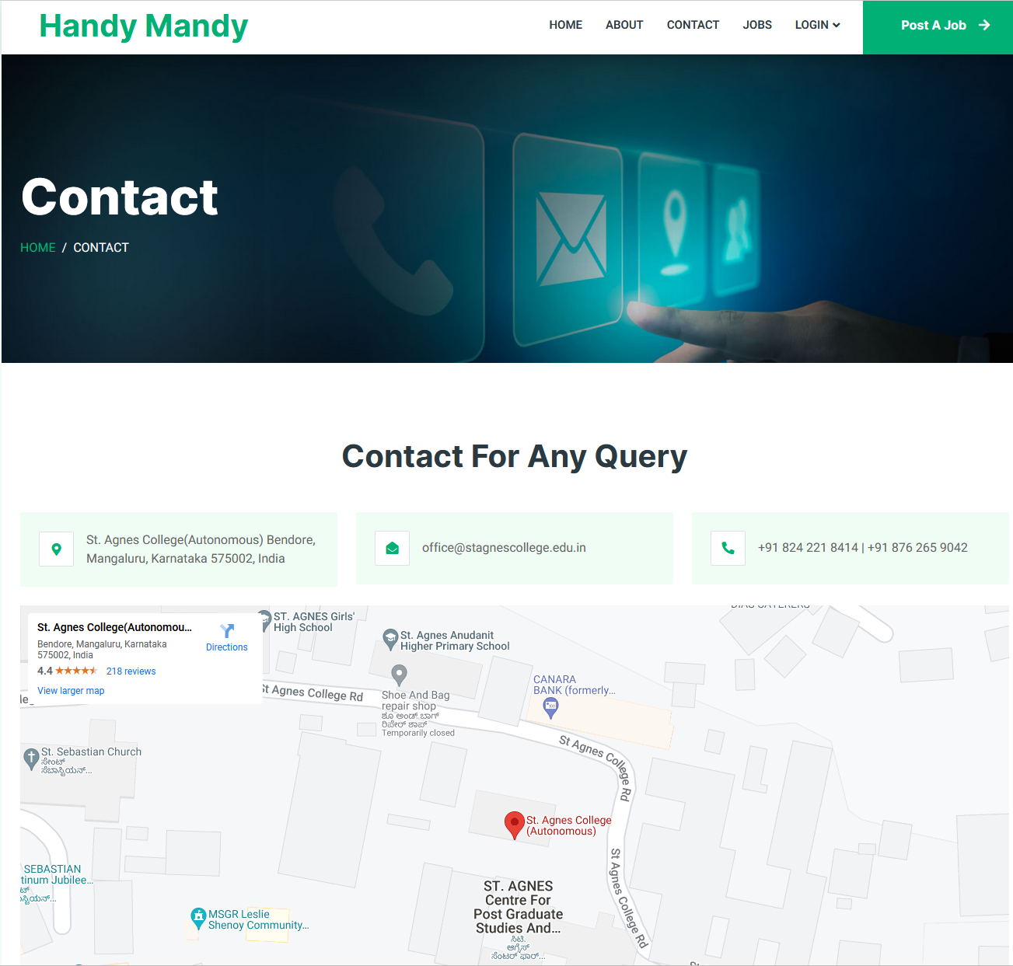

* Login for student and client

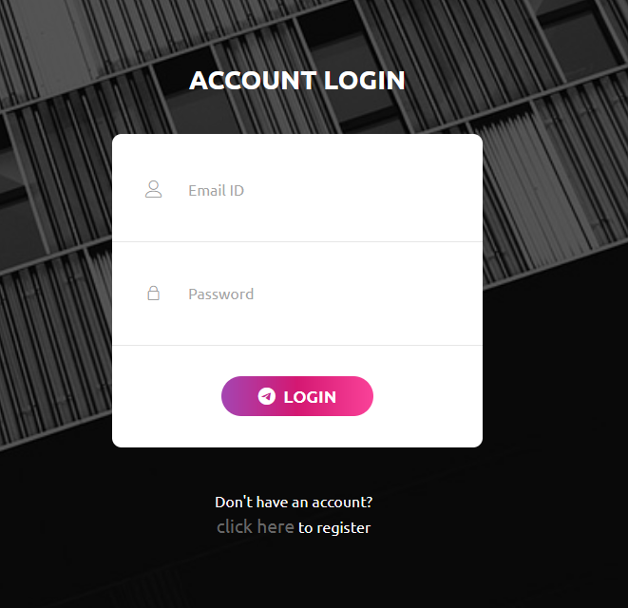

* Jobs

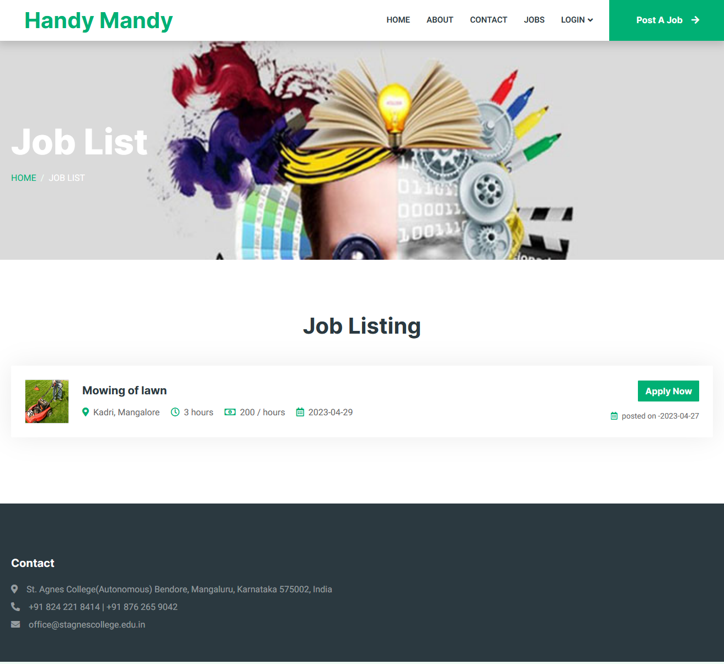

* Client Register

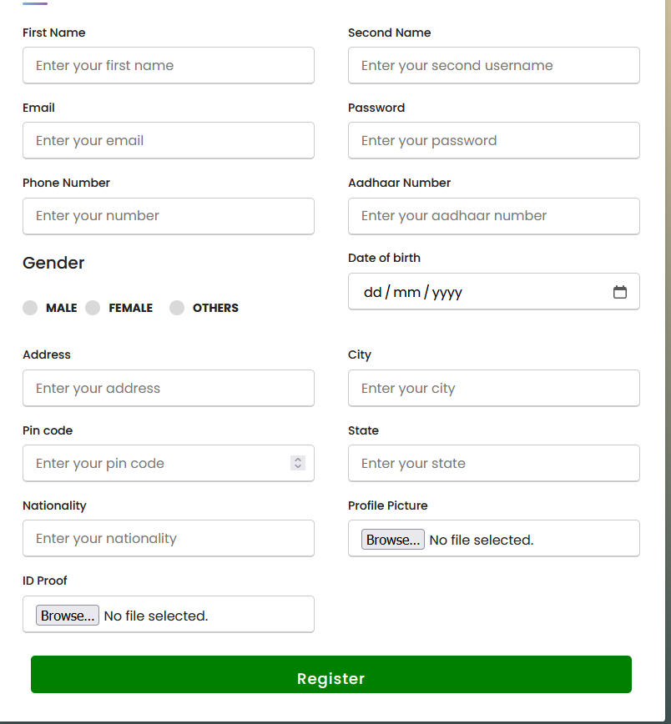

* Student register

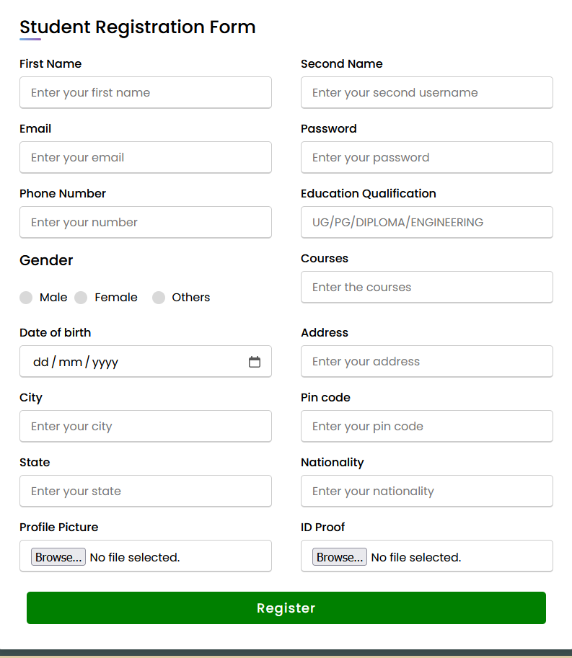

* Student profile

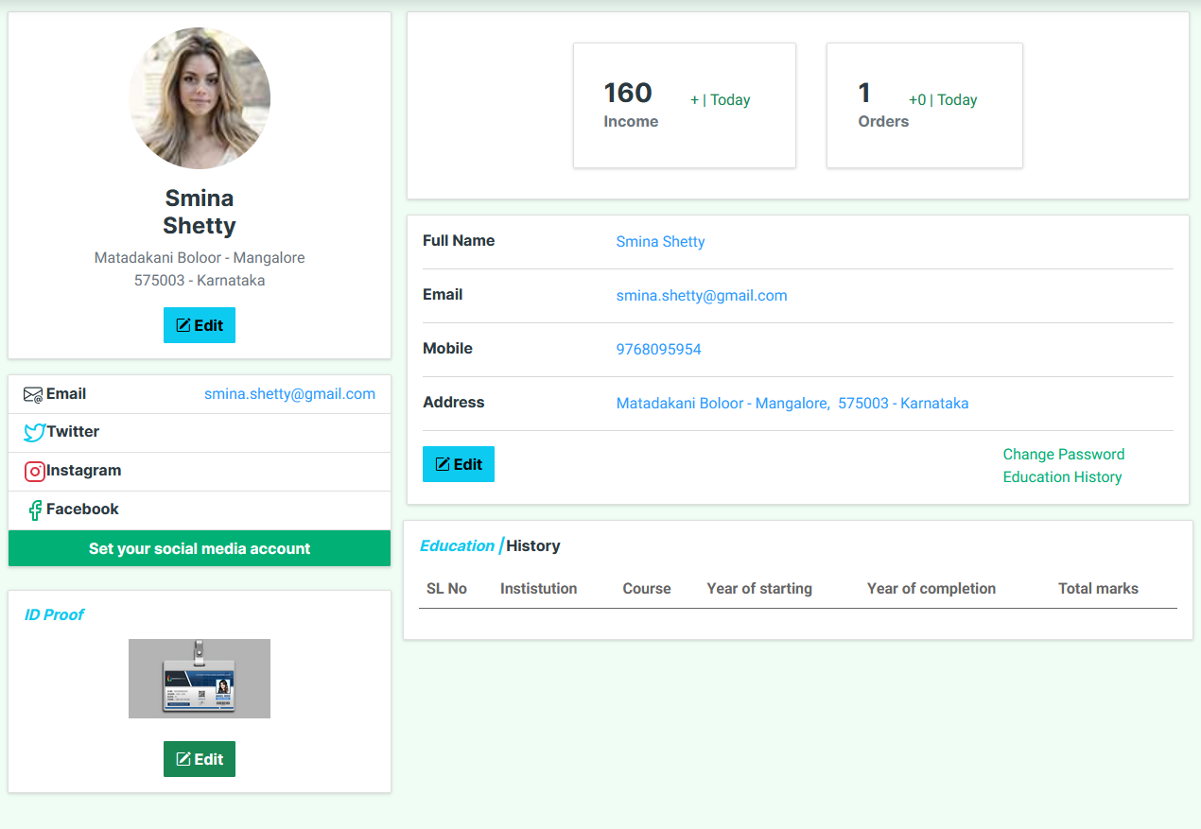

* Client profile

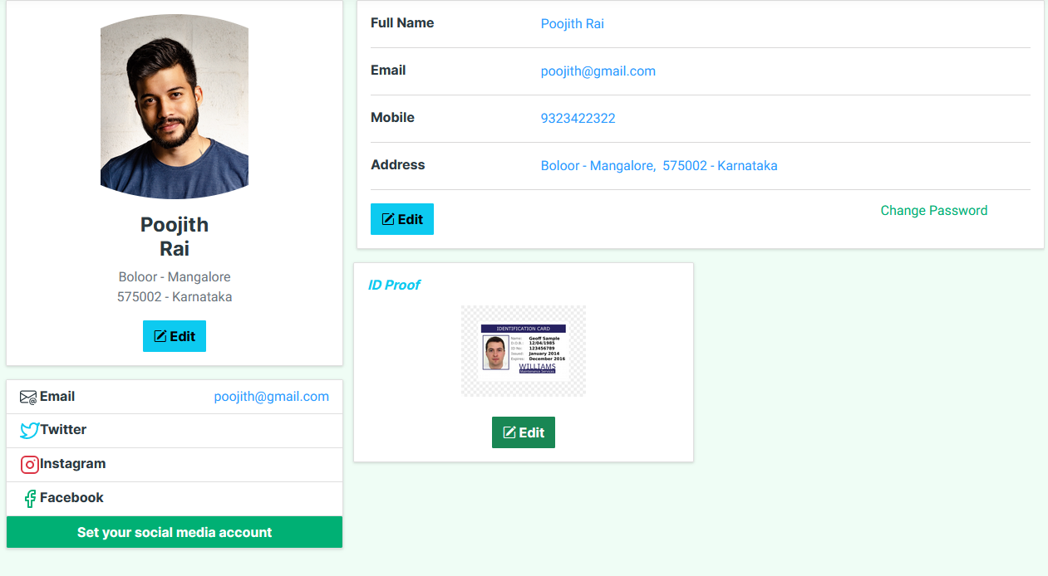

* Products

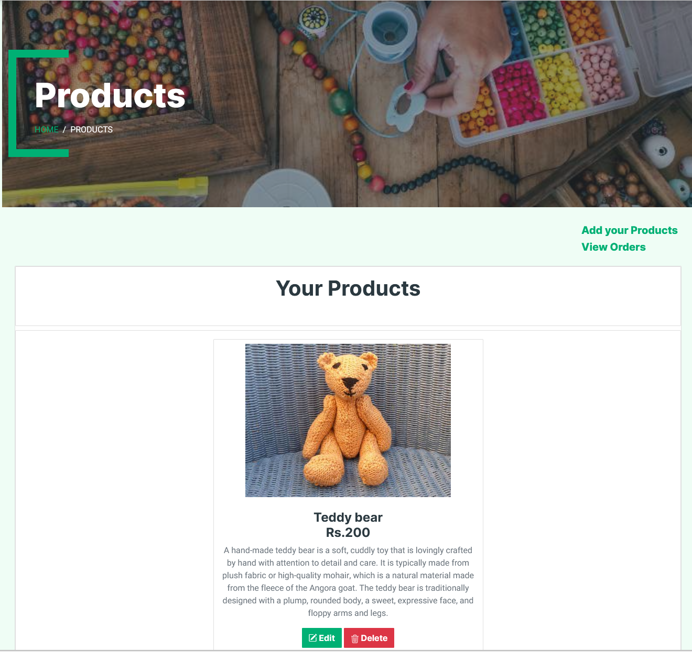

* Add products

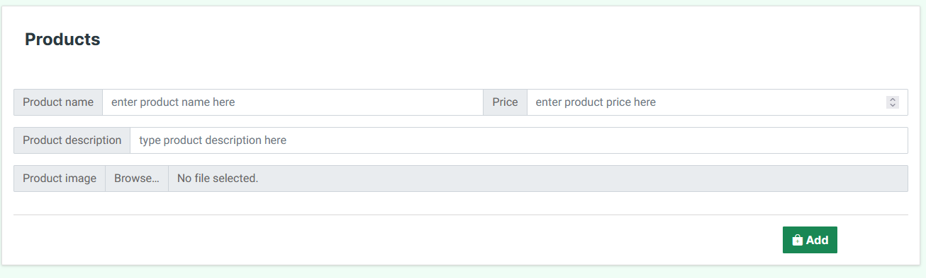

* View orders

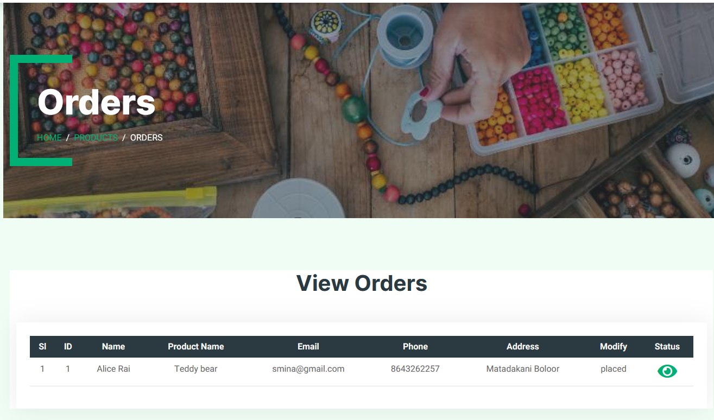

* Job list

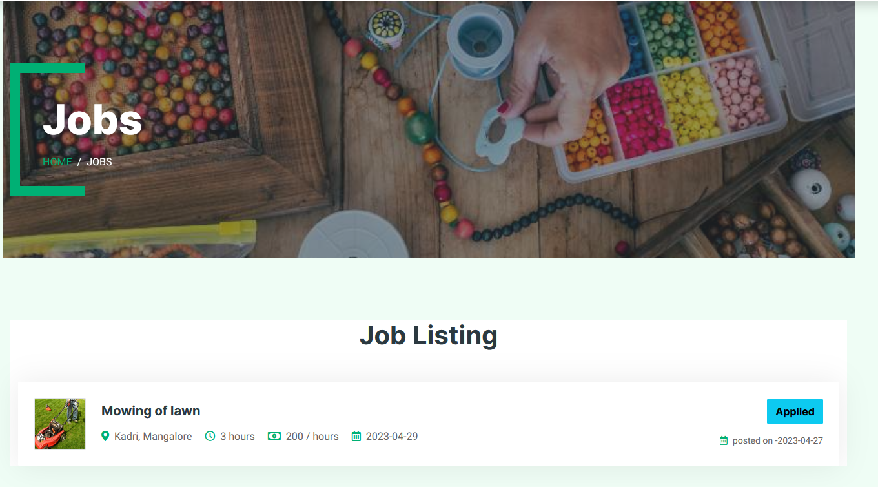

* Applied job

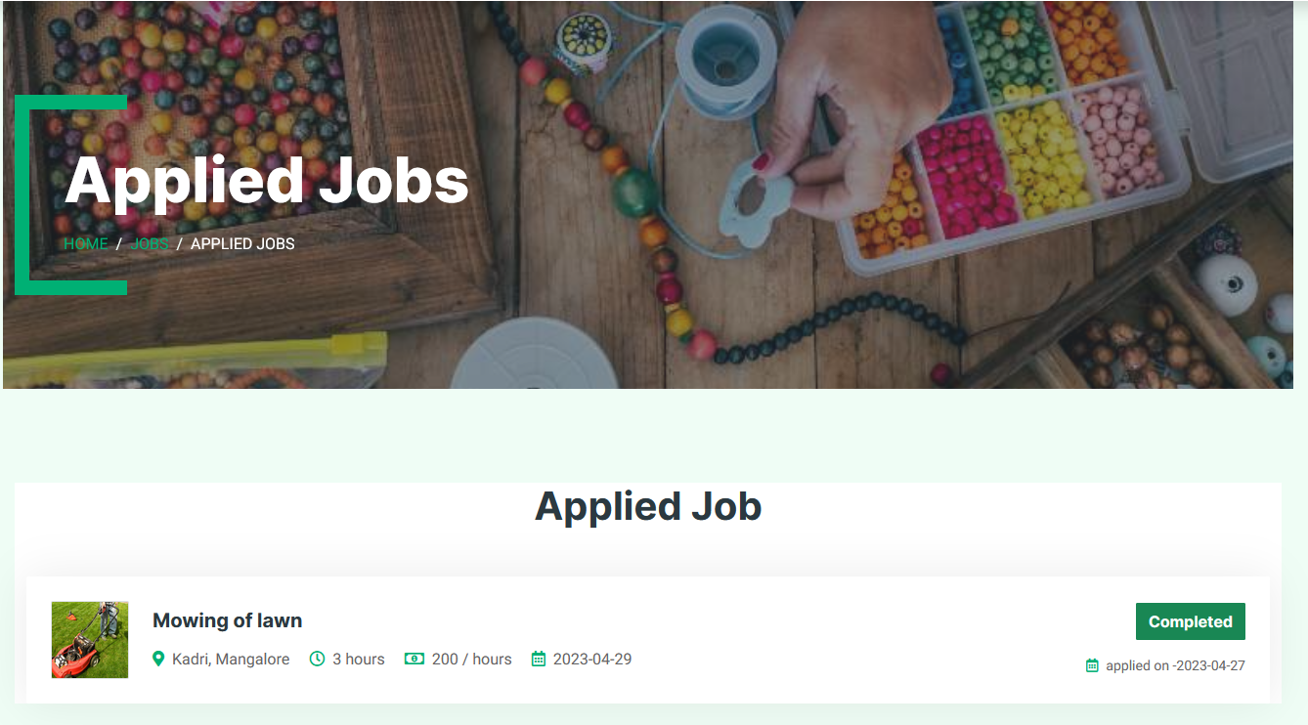

* Feedback

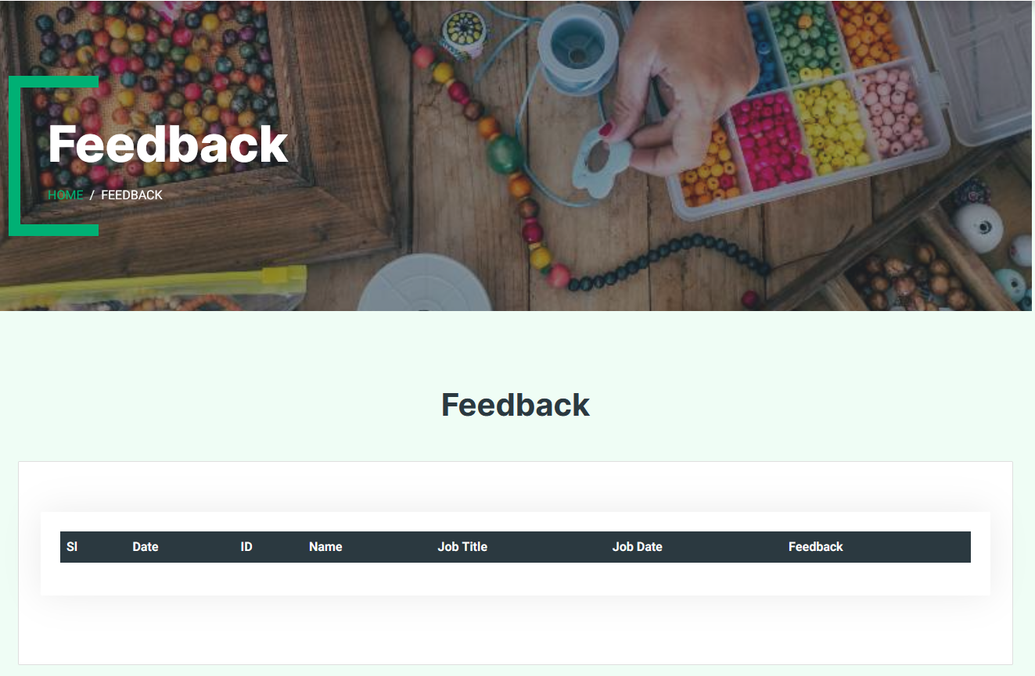

* Admin login

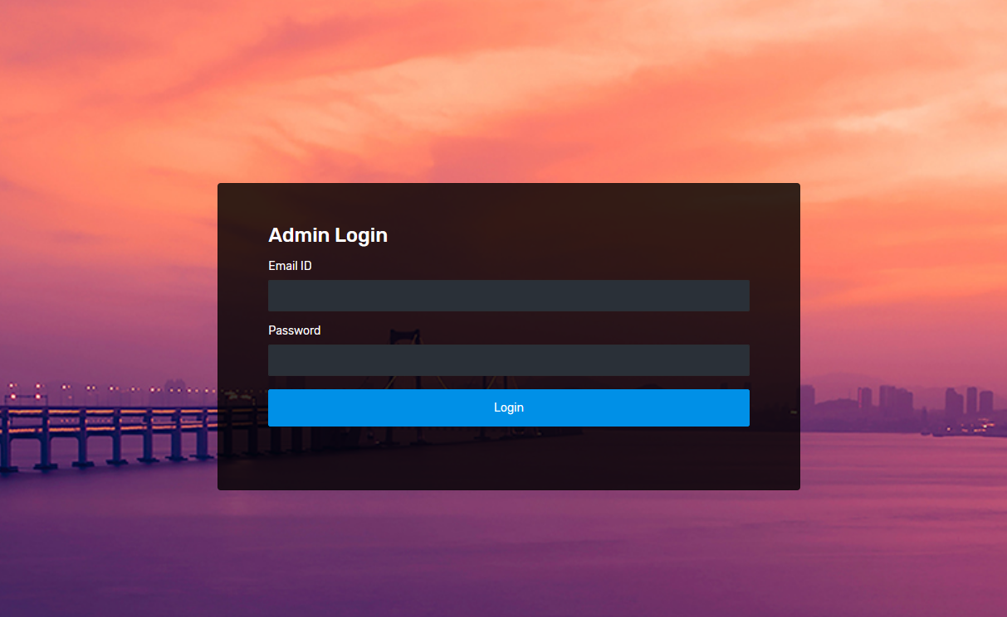

* Admin dashboard

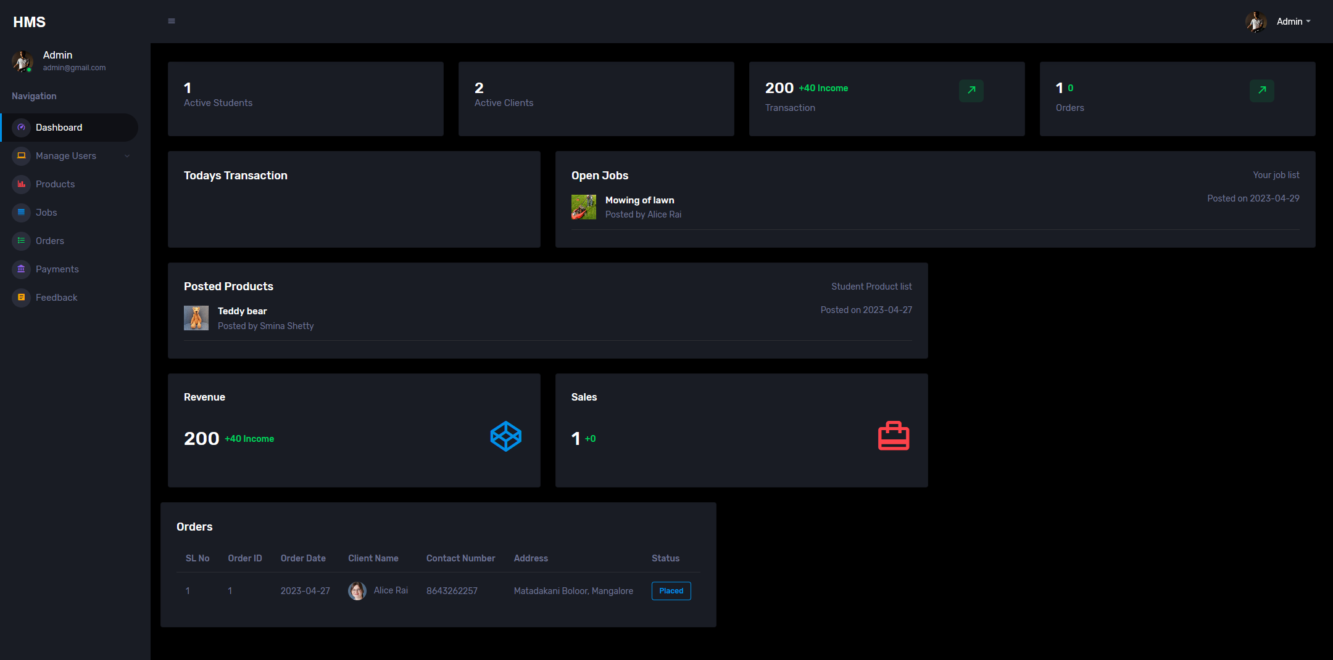

* Admin settings

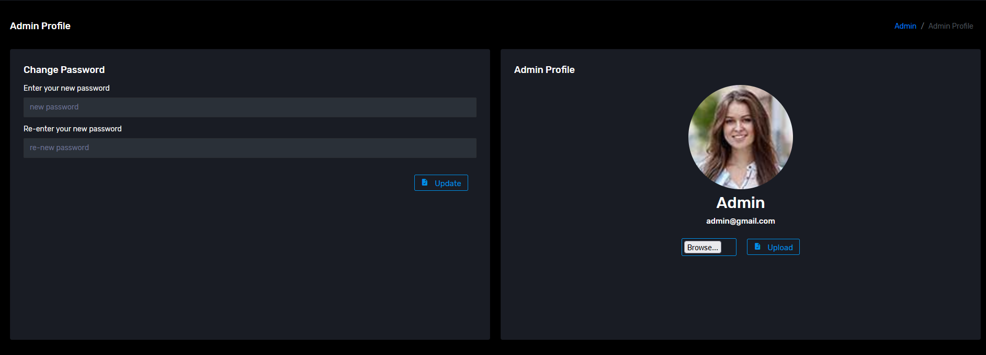

* Manage students

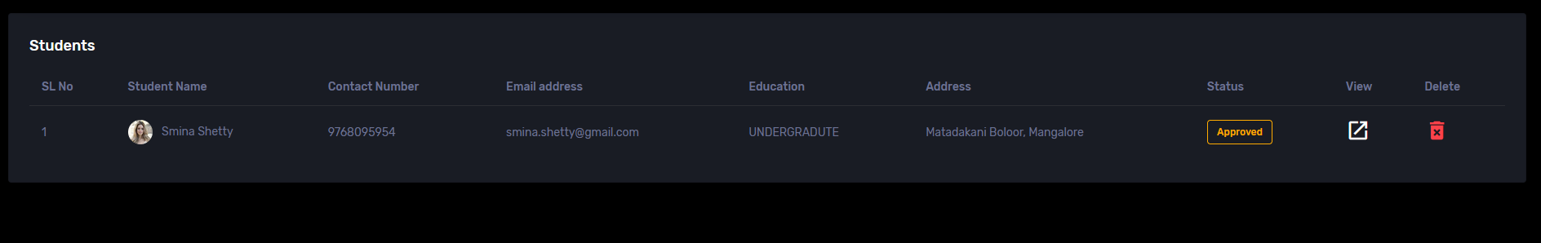

* Manage clients

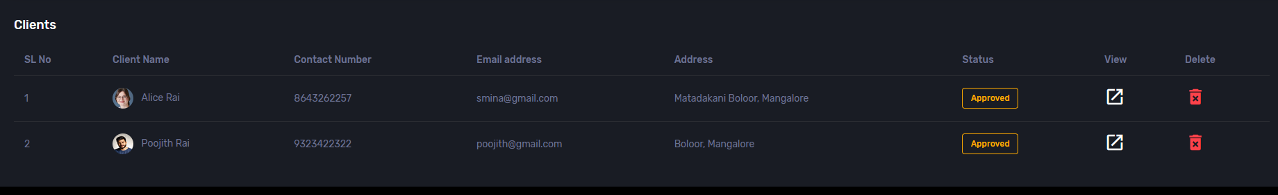

* Products

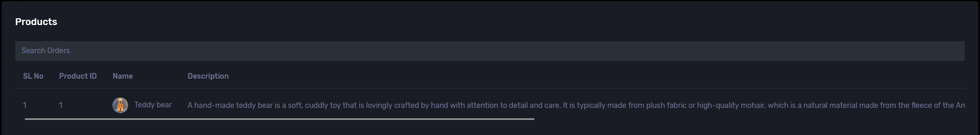

* Jobs

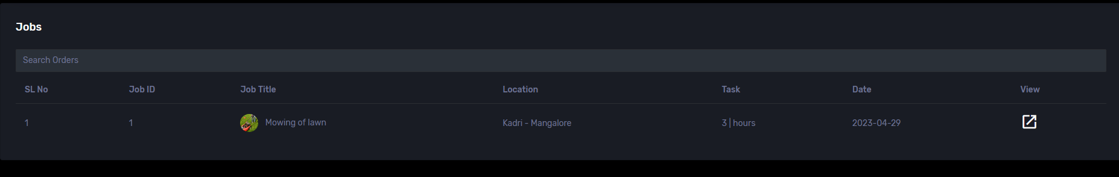

* Orders

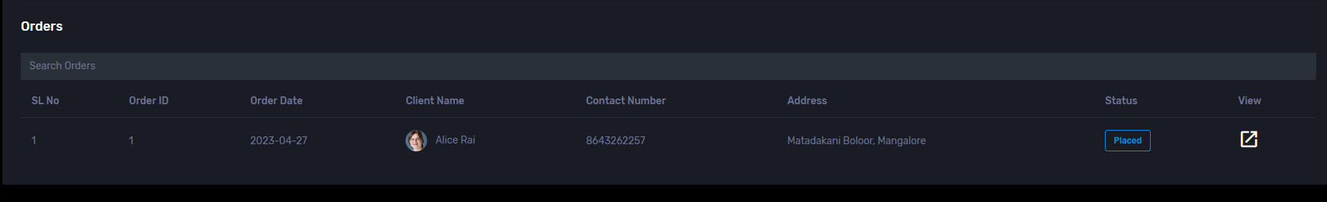

* Payments

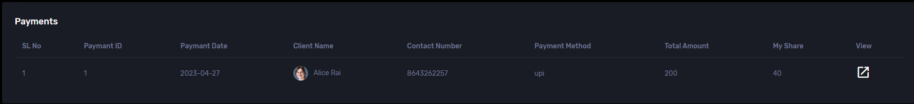

* Feedback

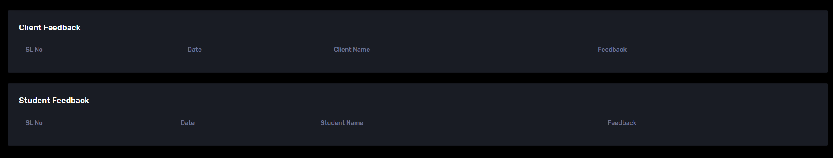

* Post a job

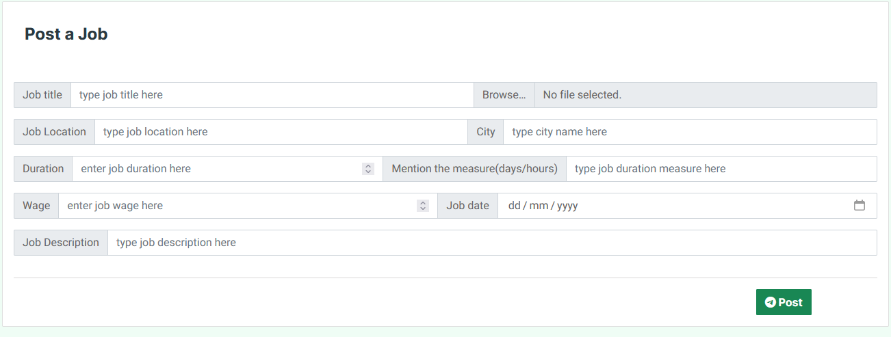

* View applicants

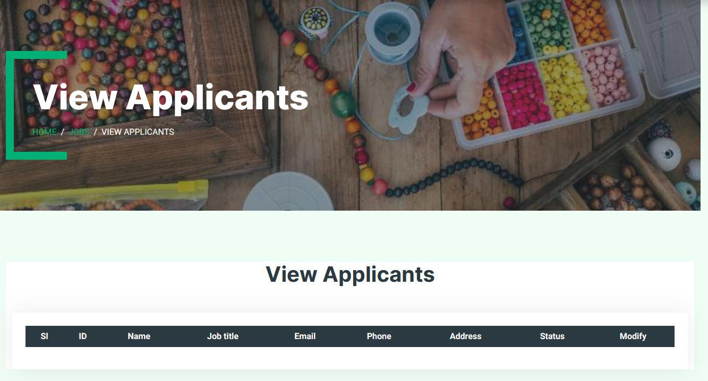

* Products

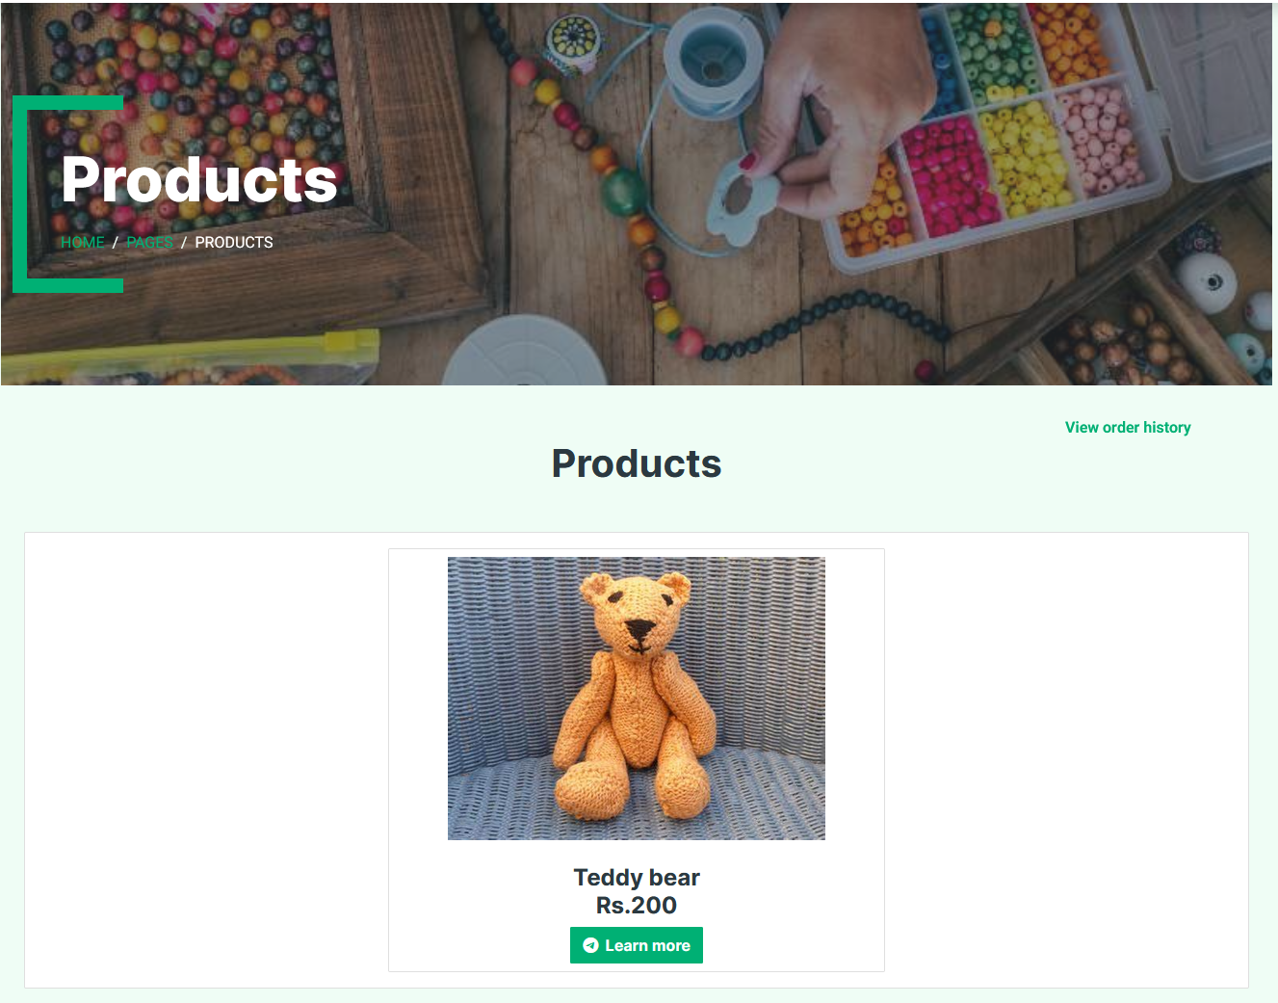

* Product details

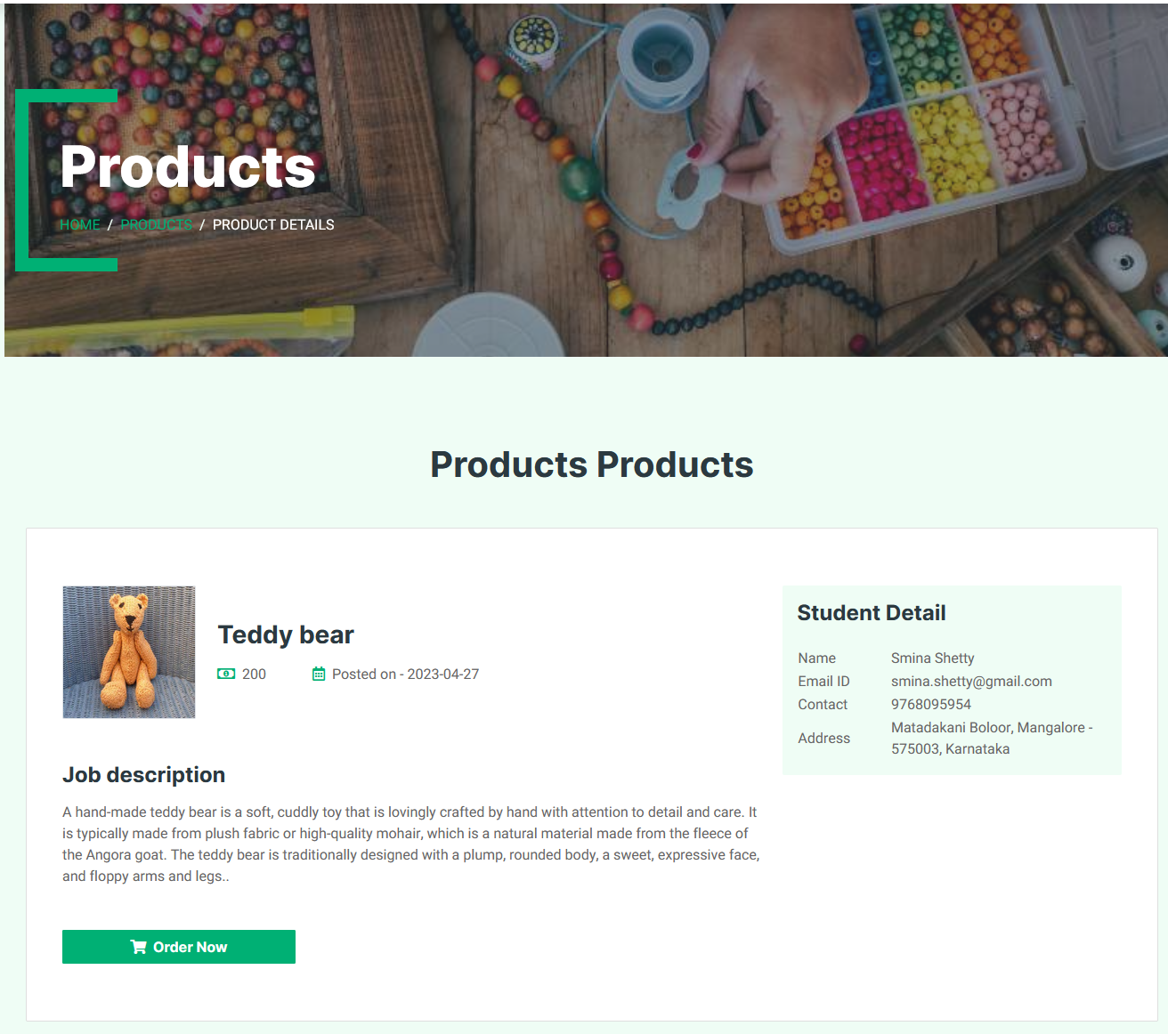

* Place orders

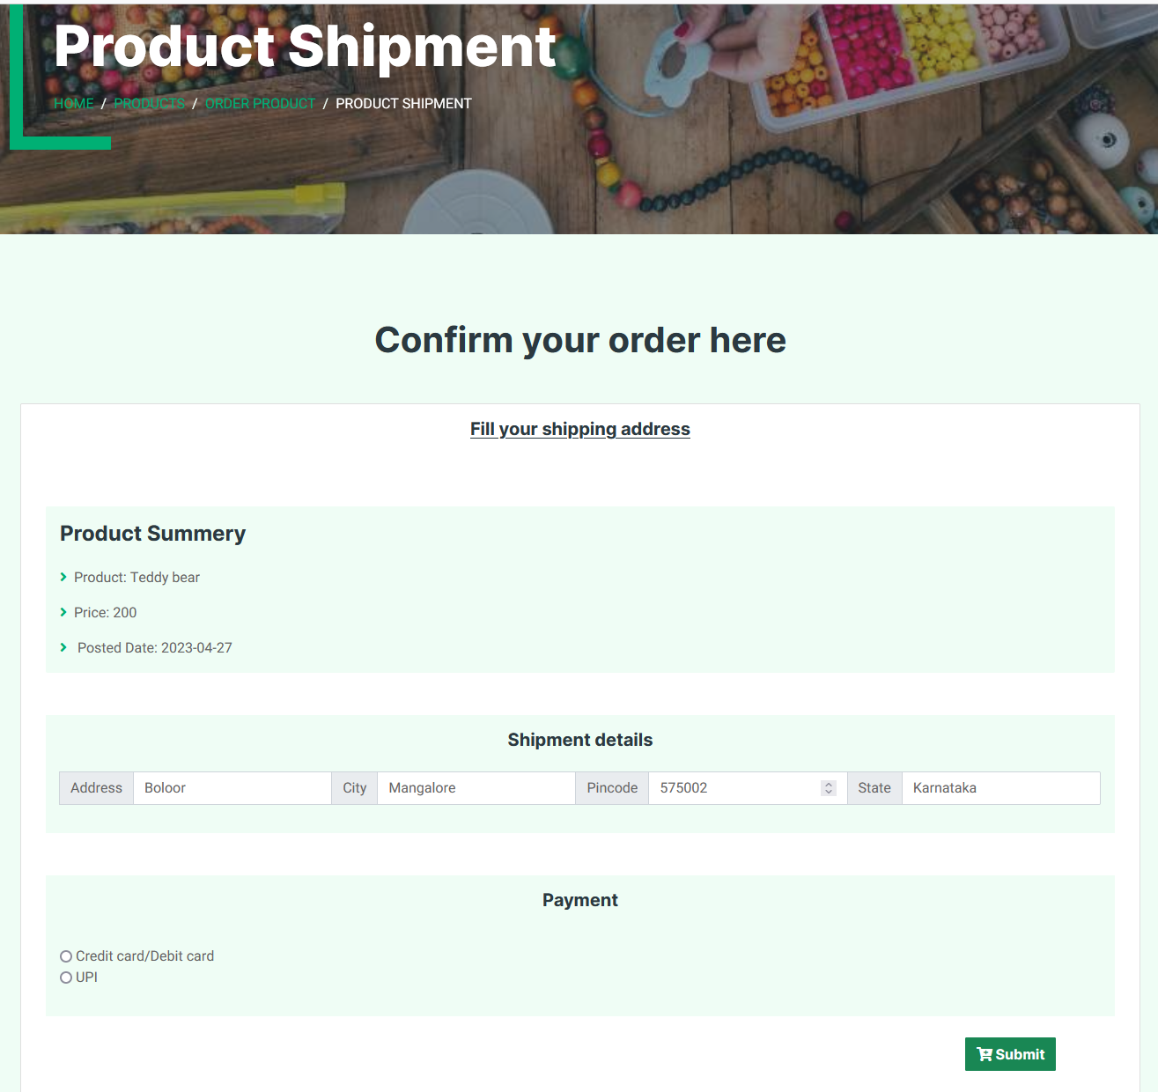

* View order history

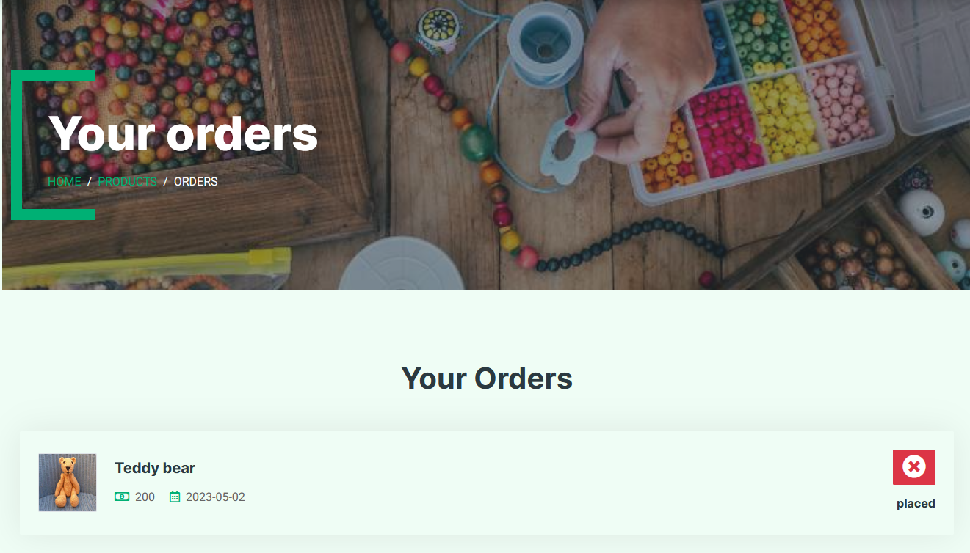

**Conclusion:**

The Project “Handy Mandy Services” was successfully tested and implemented under Windows XP & above. This web application has been developed to satisfy the needs of students and customers. The system developed is user-friendly and interactive. The system is found to be beneficial for the concerned aspects. It has been tested with all possible sample data and was found to function efficiently. The application developed is futuristic and secure. The users may add any module in future without affecting the current Project.